**INDEX**

* Exemplar
* Form
* Frames
* HTML Layout
* HTML Video & Audio
* Internal Linking
* Linking
* List
* Table with Images
* Table

1. **Exemplar**

**HTML Code**

<html>

<head>

<title>

HTML Text

</title>

</head>

<body bgcolor = "lightgray">

<center>

<h1>Use of H1.</h1>

<h2>Use of H2.</h2>

<h3>Use of H3.</h3>

<h4>Use of H4.</h4>

<h5>Use of H5.</h5>

<h6>Use of H6.</h6>

NORMAL TEXT

</center>

<hr align = "right"

noshade

width = "60%">

<hr align = "left"

Color = "#E9967A"

Width = "60%">

<B>This text has been BOLDed</B><br/>

This new line has been started by using BR tag<br/>

<I>This text has been ITALICized</I><br/>

<U>This text has been UNDERLINEd</U><br/>

<S>This text has been STRIKEDOUT</S><br/>

<BIG>This text has been BIGged</BIG><br/>

<SMALL>This text has been SMALLed</SMALL><br/>

<TT>This text has been TELETYPEd</TT><br/>

<EM>This text has been EMPHASIzed</EM><br/>

<BLOCKQUOTE>This text has been BLOCK QUOTEd </BLOCKQUOTE>

<PRE>This text

has been PREFORMATted</PRE>

<STRONG>This text has been STRONGed</STRONG><br/>

SUB<SUB>This text has been SUBSCRIPTed</SUB><br/>

SUP<SUP>This text has been SUPERSCRIPTed</SUP><br/>

</body>

</html>

**Output**

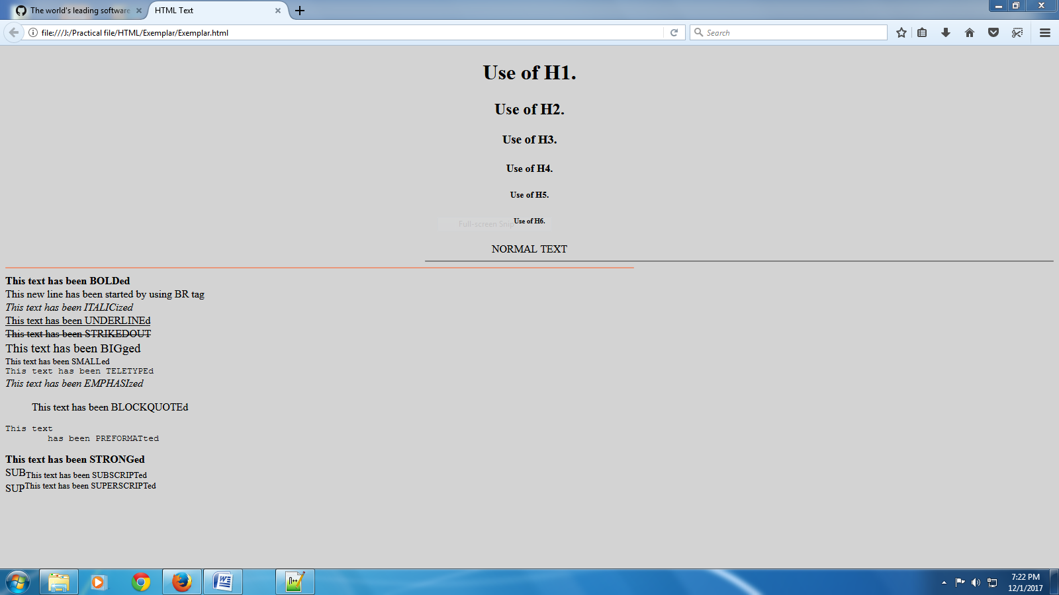

**2.Form**

**HTML Code**

<html>

<head>

<title>

ADDMISSION FORM

</title>

</head>

<body background = "../../Images/5.jpg"

Text = "#FF0000">

<h1>

<center>

<font color = "#DC143C">

<u>ADDMISSION FORM</u>

</font>

</center>

</h1>

<hr size = "5"

align = "left"

color = "#D2691E"

width = "60%">

<hr size = "5"

Align = "right"

Color = "#FF7F50"

Width = "60%">

<form>

<fieldset>

<legend>

<font color = "#FF1493">

<b>Personal Details</b>

</font>

</legend>

<table>

<tr>

<td>Enter Your Name

<td>

<select>

<option>Master.

<option>Mr.

</select>

<input type = "text"

name = "txt1">

<tr>

<td>Enter Your Mother's Name

<td>

<select>

<option>Ms.

<option>Mrs.

</select>

* <input type = "text"
  + Name = "txt2">

<tr>

<td>Enter Your Father's Name

<td>

<select>

<option>Shri

<option>Mr.

</select>

<input type = "text"

name = "txt3">

<tr>

<td>Select Your Gender

<td><input type = "radio"

name = "1"

value = "male">Male

<input type = "radio"

Name = "1"

Value = "female">Female

<tr>

<td>D.O.B

<td><input type = "text"

Name = "txt4">

</table>

</fieldset>

<fieldset>

<legend>

<font color = "#FF1493">

<b>ID Details</b>

</font>

</legend>

<table>

<tr>

<td>Aadhar Card No.

<td><input type = "text"

Name = "txt5">

<tr>

<td>Telephone/Mobile No.

<td><input type = "text"

Name = "txt6">

<tr>

<td>Nationality*

<td>

<select>

<option>Indian

<option>NRI

</select>

</table>

</fieldset>

<fieldset>

<legend>

<font color = "#FF1493">

<b>Study Details</b>

</font>

</legend>

<table>

<tr>

<td>Class for which you are seeking addmission

<td>

<select>

<option>I

<option>II

<option>III

<option>IV

<option>V<option>VI

<option>VII<option>VIII

<option>IX<option>X

<option>XI<option>XII

<tr>

<td>Stream(Only For XI & XII)

<td>

<select>

<option>Arts

<option>Commerce

<option>Medical

<option>Non-medical</select>

<tr>

<td>Additional Subject

<td><input type = "checkbox"

Name = "1"

Value = "1">Physical Education

<input type = "checkbox"

Name = "2"

Value = "2">Multimedia

<input type = "checkbox"

Name = "3"

Value = "3">Computer Science

<input type = "checkbox"

Name = "4"

Value = "4">Music

<input type = "checkbox"

Name = "5"

Value = "5">Fine arts

</table>

</fieldset>

<fieldset>

<legend>

<font color = "#FF1493">

<b>Additional Info</b>

</font>

</legend>

<table>

<tr>

<td>Enter Your ID*

<td><input type = "password"

Name = "pas1">

<tr>

<td>About You

<td>

<textarea rows = "5"

Cols = "72">

</textarea>

<tr>

<td colspan = "2"><input type = "submit"

Value = "Submit">

<input type = "reset"

Value = "Reset">

</table>

</fieldset>

<fieldset>

<table>

<tr>

<td>

*<big>

<b>--></b>

</big>Field Is Not Mandatory

<tr>

<td colspan = "2">Annual charges are

<strike>Rs.2500</strike> Rs,2399

</table>

</fieldset>

</form>

</body>

</html>



**Output**

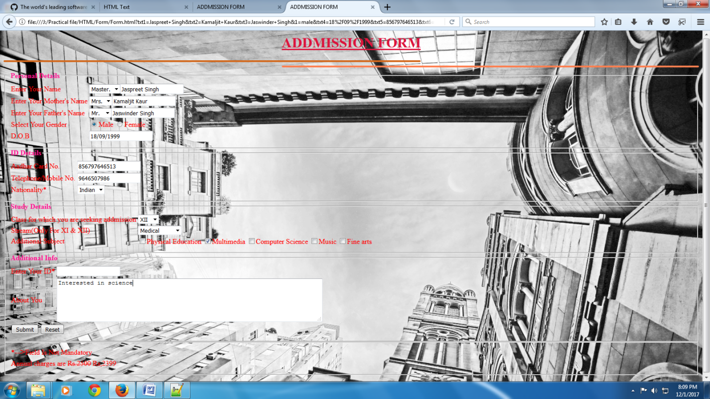

**3.Frames**

**HTML Code(Frames)**

<html>

<head>

<title>

Frame

</title>

</head>

<frameset rows = "25%,75%">

<frame src = "top.html">

<frameset cols = "30%,70%">

<frame src = "iframe.html">

<frameset rows = "60%,15%">

<frame src = "Calc.html">

<frame src = "List.html">

</frameset>

</frameset>

</frameset>

</html>

**HTML Code(Calc)**

<html>

<head>

<title>

Calcularor

</title>

<script type = "text/javascript">

function name1()

{

var name2 = prompt("Enter Your Name");

if(name2 == null)

{

frm.txt4.value = "\t Hi! Friend";

}

else

{

frm.txt4.value = "\t Hi!" + " " + name2;

}

}

function sum()

{

frm.txt3.value = parseInt(frm.txt1.value)

+ parseInt(frm.txt2.value);

}

function sub()

{

frm.txt3.value = parseInt(frm.txt1.value)

-parseInt(frm.txt2.value);

}

function multi()

{

frm.txt3.value = parseInt(frm.txt1.value)

*parseInt(frm.txt2.value);

}

function div()

{

frm.txt3.value = parseInt(frm.txt1.value)

/parseInt(frm.txt2.value);

}

function modulus()

{

frm.txt3.value = parseInt(frm.txt1.value)

%parseInt(frm.txt2.value);

}

function salary()

{

var salary1 = prompt("Enter your Salary of one day");

frm.txt3.value = salary1*30;

}

function voting1()

{

var voting2 = prompt("Enter your age");

var e = "Eligible";

var ne = "Not-Eligible";

frm.txt3.value = (voting2>18?e:ne);

}

function eval1()

{

frm.txt3.value = eval(prompt("Enter The function"));

}

function grade1()

{

var marks1 = parseInt(prompt("Enter Your Marks"));

if((marks1 >= 90) && (marks1 < 100))

{

frm.txt3.value = "A";

}

else if((marks1 >= 80) && (marks1 < 90))

{

frm.txt3.value = "B";

}

else if((marks1 >= 70) && (marks1 < 80))

{

frm.txt3.value = "C";

}

else if((marks1 >= 60) && (marks1 < 70))

{

frm.txt3.value = "D";

}

else if((marks1 > = 50) && (marks1 < 60))

{

frm.txt3.value = "E";

}

else if((marks1 >= 40) && (marks1 < 50))

{

frm.txt3.value = "F";

}

else

{

frm.txt3.value = "FAIL!";

}

}

</script>

</head>

<body bgcolor = "#E9967A"

Onload = "name1()"

Background = "../../Images/1.svg">

<h1 style = "color:#CD5C5C">

<center>

<u>

Calculator

</u>

</center>

</h1>

<form name = "frm">

<center>

<table border = "1"

Background = "../../Images/4 (2).jpg">

<tr>

<td colspan = "2">

<center>

<input type = "text"

Name = "txt4"

Value = "Hi! friend"

readonly>

</center>

</td>

</tr>

<tr>

<td>

<b>Enter First Value</b>

</td>

<td>

<input type = "text"

Name = "txt1"

Size = "8%">

</td>

<tr>

<td>

<b>Enter second Value</b>

<td>

<input type = "text"

Name = "txt2"

Size = "8%">

<tr>

<td>

<center>

<input type = "button"

Value = "+"

onClick = "sum()">

</center>

<td>

<center>

<input type = "button"

Value = "-"

onClick = "sub()">

</center>

<tr>

<td>

<center>

<input type = "button"

Value = "*"

onClick = "multi()">

</center>

<td>

<center>

<input type = "button"

Value = "/"

onClick = "div()">

</center>

<tr>

<td>

<center>

<input type = "button"

Value = "%"

onclick = "modulus()">

</center>

<td>

<center>

<input type = "button"

Value = "Salary"

onclick = "salary()">

</center>

<tr>

<td>

<center>

<input type = "button"

Value = "Voting"

Onclick = "voting1()">

</center>

<td>

<center>

<input type = "button"

Value = "Evaluate"

Onclick = "eval1()">

</center>

<tr>

<td colspan = "2">

<center>

<input type = "button"

Value = "Grade"

Onclick = "grade1()">

</center>

<tr>

<td>

<b>Result</b>

<td>

<input type = "text"

Name = "txt3"

Size = "8%"

readonly>

<tr>

<td colspan = "2">

<center>

<input type = "Reset"

Value = "Reset">

</table>

</center>

</form>

</body>

</html>

**HTML Code (iframe)**

<html>

<head>

<title>

Data

</title>

<link href = "5.css"

Rel = "stylesheet"

Type = "text/css">

</head>

<body id = "diff">

<form>

<fieldset>

<legend>Fill The Given Information</legend>

<table>

<tr>

<td>Username

<td>

<input type = "textbox"

Placeholder = "Enter Your Id" name = "user">

<tr>

<td>Password

<td>

<input type = "password"

Placeholder = "Enter Your Password"

Name = "password"></tr>

</table>

<br>

</fieldset>

</form>

<iframe src = "..\Form\Form.html">

</body>

</html>

**HTML Code(List)**

<html>

<head>

<style>

ul

{

list-style-type : none;

margin : 0;

padding : 0;

overflow : hidden;

background-color : #333;

}

li

{

Float : left;

}

li a

{

Display : block;

Color : white;

text-align : center;

padding : 14px 16px;

text-decoration : none;

}

li a : hover : not(.active)

{

background-color : #111;

}

.active

{

background-color : #4CAF50;

}

</style>

</head>

<body>

<ul>

<li><a href = "#home">Home</a></li>

<li><a href = "#news">News</a></li>

<li><a href = "#contact">Contact</a></li>

<li style = "float : right"><a class = "active"

Href = "#about">About</a></li>

</ul>

</body>

</html>

**HTML Code(top)**

<html>

<head>

<TITLE>

Top

</title>

<link href = "5.css"

Rel = "stylesheet"

Type = "text/css">

</head>

<body>

<H1>Pure Education</h1>

</body>

</html>

**Output**

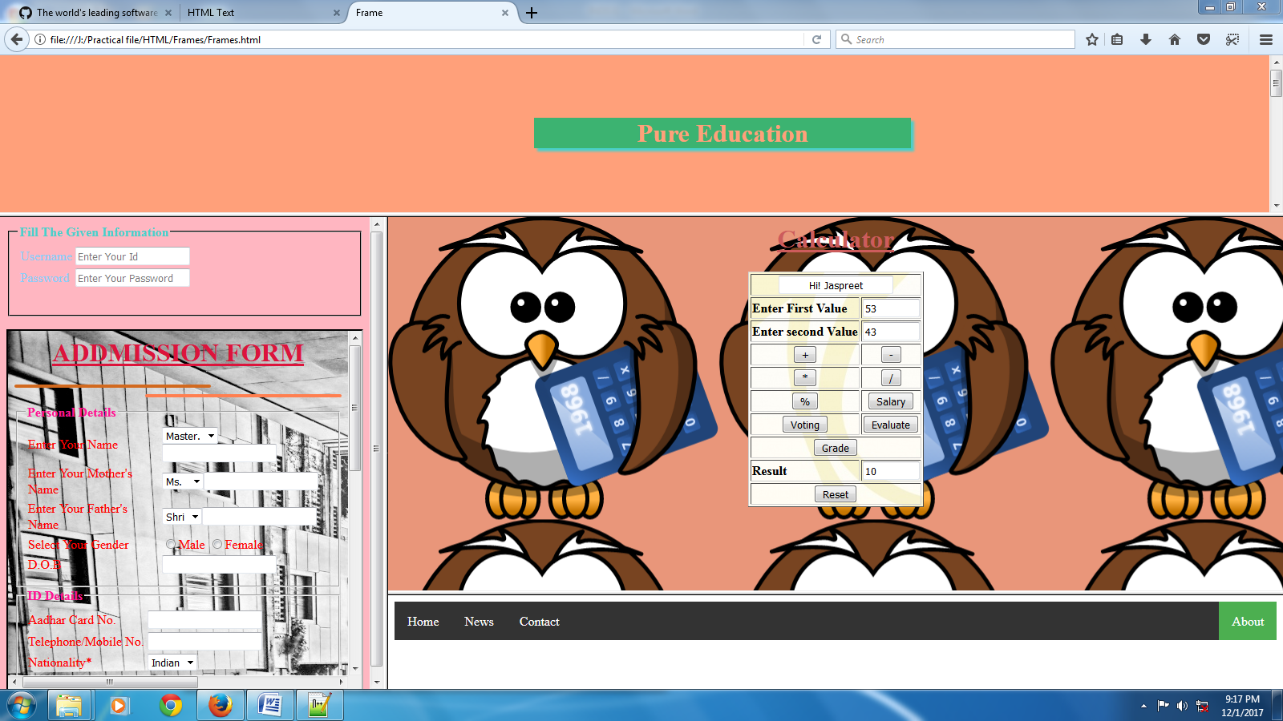

**4.HTML Layout**

**HTML Code**

<html>

<head>

<style>

div.container

{

Width : 100%;

Border : 1px solid gray;

}

header, footer

{

Padding : 1em;

Color : white;

background-color : black;

clear : left;

text-align : center;

}

nav

{

Float : left;

max-width : 160px;

margin : 0;

padding : 1em;

}

nav ul

{

list-style-type : none;

padding : 0;

}

nav ul a

{

text-decoration : none;

}

article

{

margin-left : 170px;

border-left : 1px solid gray;

padding : 1em;

overflow : hidden;

}

</style>

</head>

<body>

<div class = "container">

<header>

<h1>City Gallery</h1>

</header>

<nav>

<ul>

<li><a href = "#">London</a></li>

<li><a href = "#">Paris</a></li>

<li><a href = "#">Tokyo</a></li>

</ul>

</nav>

<article>

<h1>London</h1>

<p>

London is the capital city of England. It is the mostpopulous city in the United Kingdom,

with a metropolitan area of over 13 million inhabitants.

</p>

<p>

Standing on the River Thames, London has been a major settlement for two millennia, its

history going back to its founding by the Romans, who named it Londinium.

</p>

</article>

<footer>Copyright &copy; London</footer>

</div>

</body>

</html>

**Output**

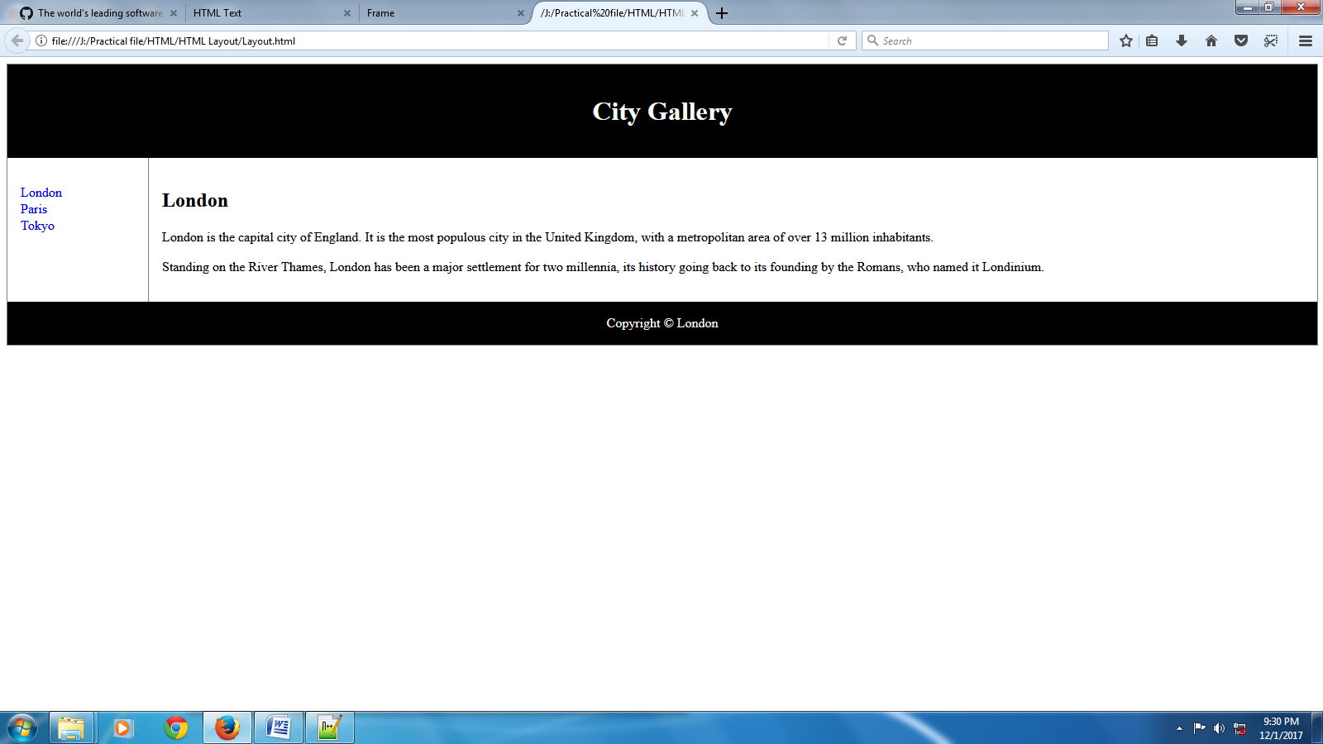

**5.HTML Video & Audio**

**HTML Code**

<html>

<body>

<video width = "400"

controls>

<source src = "mov_bbb.mp4"

Type = "video/mp4">

Your browser does not support HTML5 video.

</video>

<p>

Video courtesy of

<a href = "https://www.bigbuckbunny.org/"

Target = "_blank">Big Buck Bunny</a>.

</p>

<audio controls>

<source src = "horse.ogg"

Type = "audio/ogg">

Your browser does not support the audio element.

</audio>

</body>

</html>

**Output**

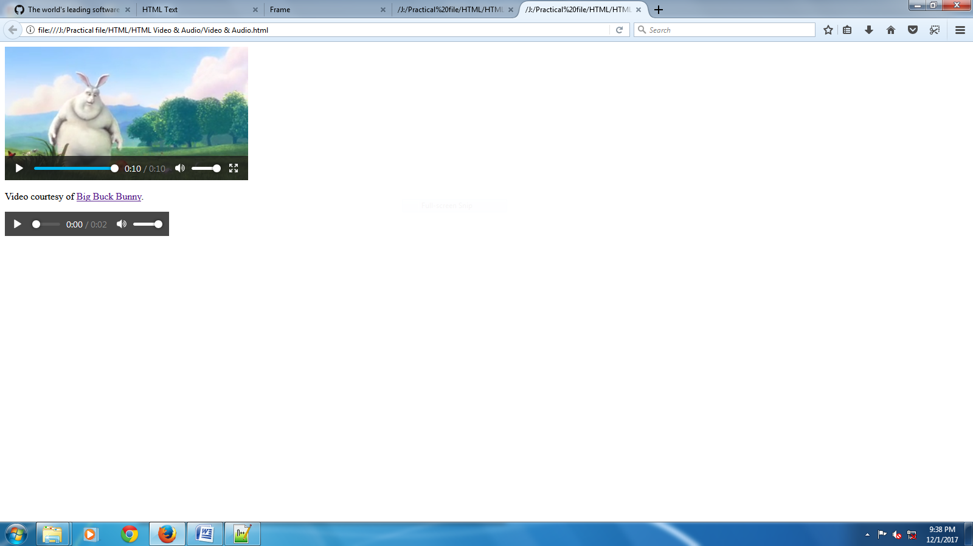

**6.Internal Linking**

**HTML Code**

<html>

<head>

<title>Monday Times</title>

<style>

body

{

font-family : Verdana,sans-serif;

font-size : 0.9em;

}

div#header, div#footer

{

Padding : 10px;

Color : white;

background-color : black;

}

div#content

{

Margin : 5px;

Padding : 10px;

background-color : lightgrey;

}

div.article

{

Margin : 5px;

Padding : 10px;

background-color : white;

}

div#menu ul

{

Padding : 0;

}

div#menu ul li

{

Display : inline;

Margin : 5px;

}

div.cities

{

background-color : black;

color : white;

margin : 20px 0 20px 0;

padding : 20px;

}

</style>

</head>

<body>

<div id = "header">

<h1>Monday Times</h1>

</div>

<div id = "menu">

<ul>

<li>News</li>

<li>Sports</li>

<li>Weather</li>

</ul>

</div>

<div id = "content">

<h2>Wonderful Cities</h2>

<div class = "article">

<h2>London</h2>

<p>

London is the capital of England. It is the most populous city in the United Kingdom, with a metropolitan area of over 13 million inhabitants.

</p>

<p>

Standing on the River Thames, London has been a major settlement for two millennia, its history going back to its founding by the Romans, who named it Londinium.

</p>

<a href = "#London"

Style = "text-decoration : none;">

Learn More...</a>

</div>

<div class = "article">

<h2>Paris</h2>

<p>

Paris is the capital and most populous city of France.

</p>

<p>

Situated on the Seine River, it is at the heart of the ÃŽle-de-France region, also known as

the rÃ©gion parisienne.

</p>

<p>

Within its metropolitan area is one of the largest population centers in Europe, with over 12 million inhabitants.

</p>

<a href = "#Paris"

Style = "text-decoration : none;">

Learn More...</a>

</div>

<div class = "article">

<h2>Tokyo</h2>

<p>

Tokyo is the capital of Japan, the center of the Greater Tokyo Area, and the most populous metropolitan area in the world.

</p>

<p>

It is the seat of the Japanese government and the Imperial Palace, and the home of the Japanese Imperial Family.</p>

<p>

The Tokyo prefecture is part of the world's most populous metropolitan area with 38 million people and the world's largest urban economy.

</p>

<a href = "#Tokyo"

Style = "text-decoration : none;">

Learn More...</a>

</div>

</div>

<a name = "London">

<div class = "cities">

<h2>London</h2>

<p>

London is the capital of England. It is the most populous city in the United Kingdom, with a metropolitan area of over 13 million inhabitants.

</p>

<p>

Standing on the River Thames, London has been a major settlement for two millennia, its history going back to its founding by the Romans, who named it Londinium.

</p>

</div>

</a>

<a name = "Paris">

<div class = "cities">

<h2>Paris</h2>

<p>

Paris is the capital and most populous city of France.

</p>

<p>

Situated on the Seine River, it is at the heart of the ÃŽle-de-France region, also known as the rÃ©gion parisienne.

</p>

<p>

Within its metropolitan area is one of the largest population centers in Europe, with over

12 million inhabitants.

</p>

</div>

</a>

<a name = "Tokyo">

<div class = "cities">

<h2>Tokyo</h2>

<p>

Tokyo is the capital of Japan, the center of the Greater Tokyo Area, and the most populous metropolitan area in the world.

</p>

<p>

It is the seat of the Japanese government and the Imperial Palace, and the home of the

Japanese Imperial Family.

</p>

<p>

The Tokyo prefecture is part of the world's most populous metropolitan area with 38 million people and the world's largest urban economy.

</p>

</div>

</a>

<div id = "footer">

<p>&copy; 2014 Monday Times. All rights reserved.</p>

</div>

</body>

</html>

**Output**

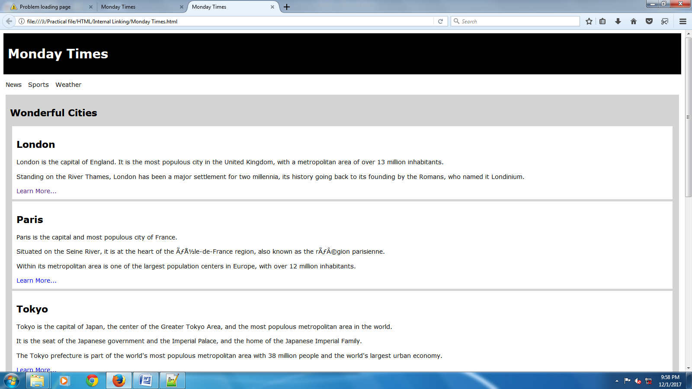

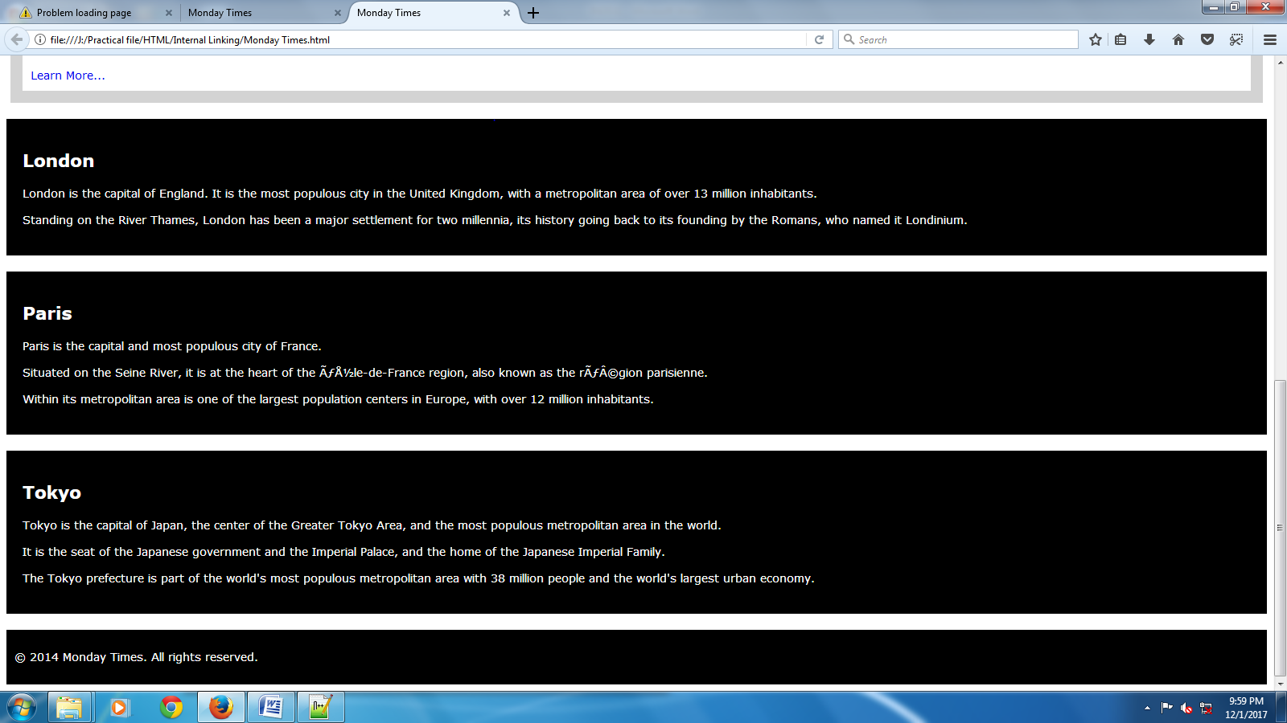

**7.Linking**

**HTML Code**

<html>

<head>

<title>Linking</title>

</head>

<body bgcolor = "orange"

Text = "Red"

Link = "Green"

Vlink = "blue"

Alink = "grey">

<h1>

<center>

<font color = "green">

<U>Gallery</u>

</font>

</center>

</h1>

<p>

Here you can see some of the glimpses of Indian Army,Navy and Air Force.

</p>

<ol>

<li><a href = "11.jpg">Indian Land Army</a>

<li><a href = "22.jpg">Indian Navy</a>

<li><a href = "33.jpg">Indian Air Force</a>

</ol>

</body>

</html>

**Output**

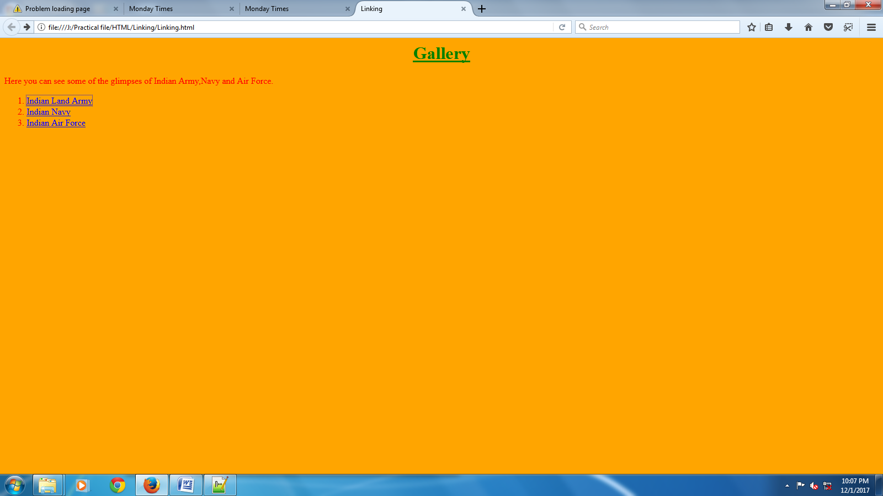

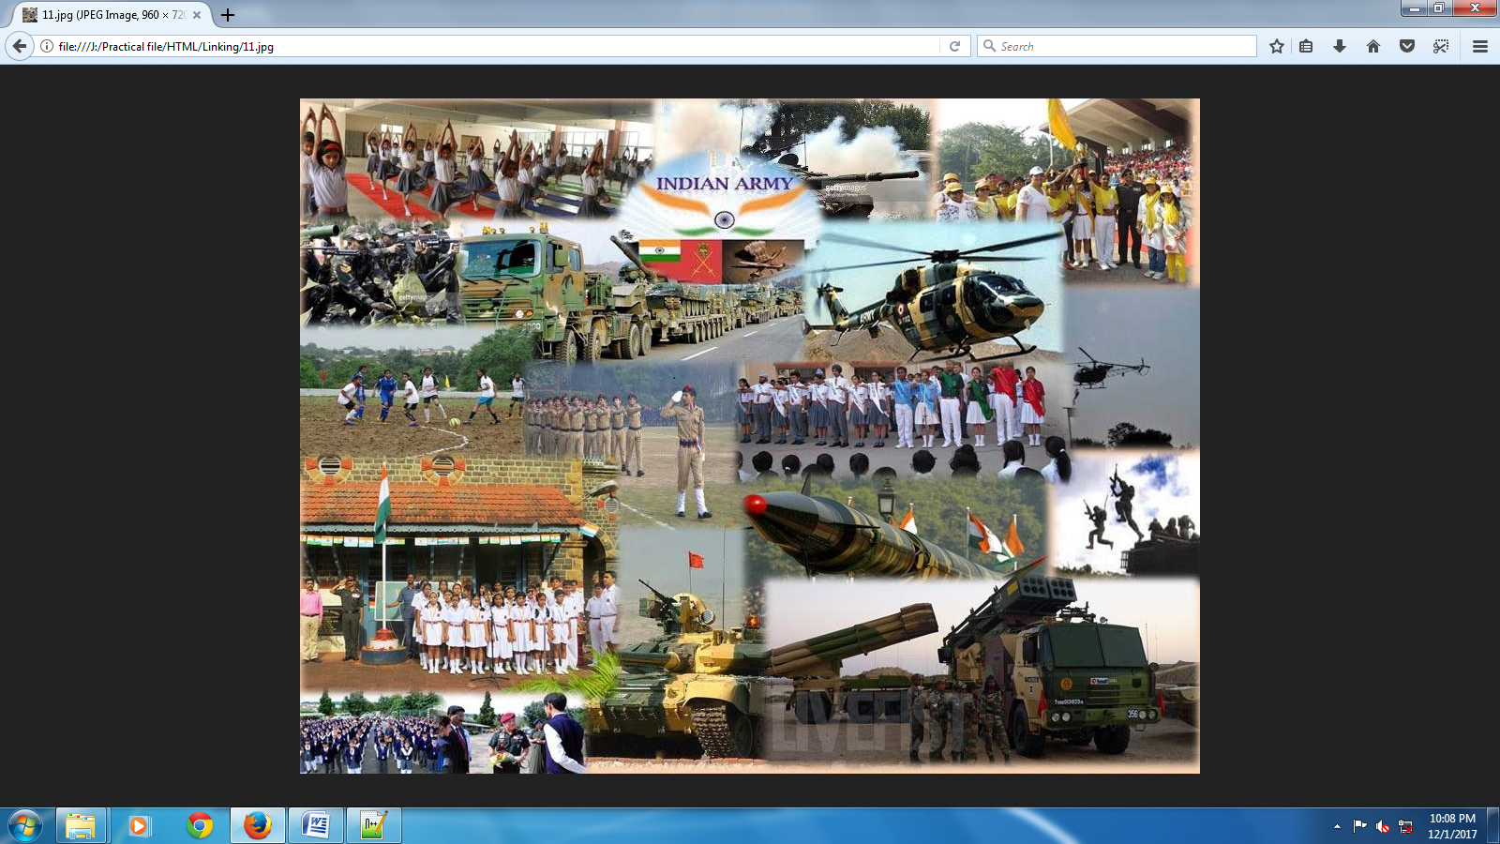

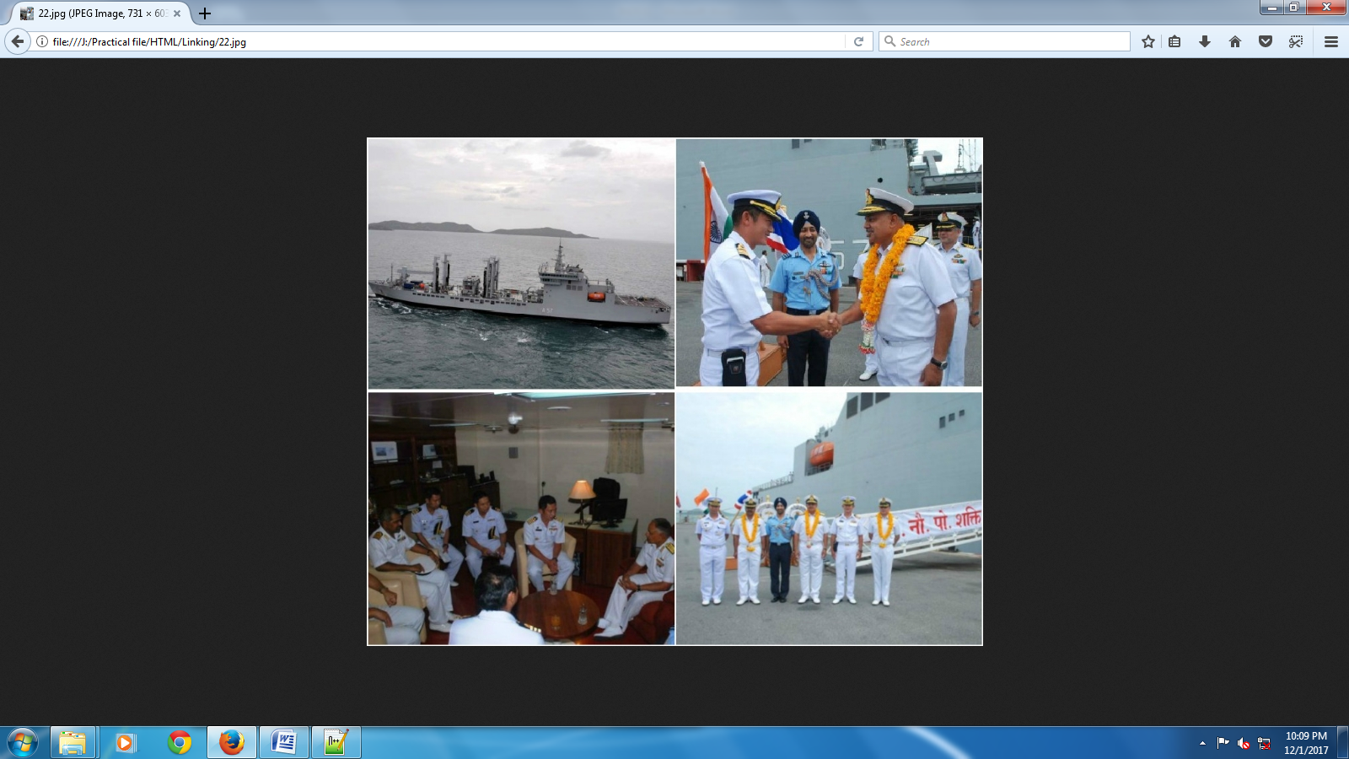

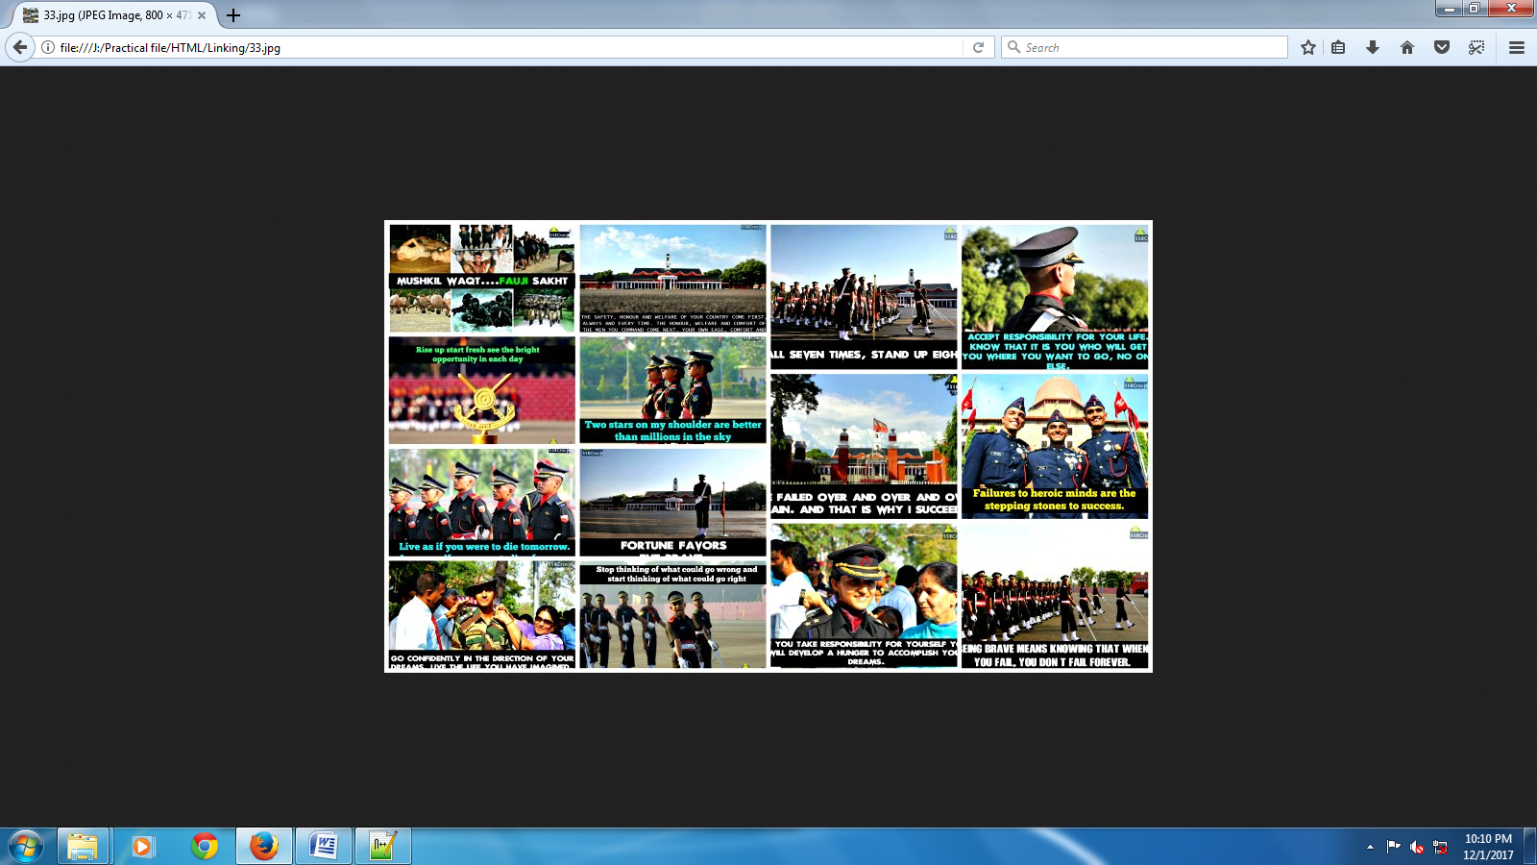

**8.List**

**HTML Code**

<html>

<head>

<title>Mendalian Experiment</title>

</head>

<body bgcolor = "#ff751a">

<basefont face = "Times New Roman"

Size = "10">

<font color = "red">

<center>

<h1><u>Mendalian Experiment</u></h1>

</center>

</font>

<dl>

<dt><u>Introduction:</u>

<dd>

To understand heredity Gregor Johann Mendel in 1857 started his own breeding experiments which were intended to give information about heredity and evolution. After careful consideration,he selected garden pea andconducted

hybridisation experiments with its various varieties for eight years.Mendel took into consideration seven characters of the garden pea.Each of these seven characters has two varieties or alternatives.

</dl>

<font color = "green">

<center>

<h3><u>Monohybrid Experiment</u></h3>

</center>

</font>

<table border = "3"

Align = "center"

Width = "30%">

<caption>First Progeny:T-Tall & t-Short</caption>

<tr>

<td>

<ul type = "square">

<li>TT

<li>tt

</ul>

<th>T

<th>T

<tr>

<th>t

<td>Tt

<td>Tt

<tr>

<th>t

<td>Tt

<td>Tt

</table>

<table border = "3"

Align = "center"

Width = "30%">

<caption>Second Progeny:T-Tall & t-Short</caption>

<tr>

<td>

<ul type = "square">

<li>Tt

<li>Tt

</ul>

<th>T

<th>t

<tr>

<th>T

<td>TT

<td>Tt

<tr>

<th>t

<td>Tt

<td>tt

</table>

<h5><u>Results</u></h5>

<ol>

<li>First Progeny(Cross Breeding)

<ul>

<li>Tall:4

<li>Short:0

</ul>

<li>Second Progeny(Self Breeding)

<ul>

<li>Tall:3

<li>Short:1

</ul>

</ol>

<font color="green">

<center>

<h3><u>Dihybrid Experiment</u></h3>

</center>

</font>

<table border = "3"

Align = "center"

Width = "30%">

<caption>First Progeny:R-Round,r:Wrinkled,Y:Yellow & y:green</caption>

<tr>

<td><ul type="square">

<li>RRYY

<li>rryy

</ul>

<th>RY

<th>RY

<tr>

<th>ry

<td>RrYy

<td>RrYy

<tr>

<th>ry

<td>RrYy

<td>RrYy

</table>

<table border="3"

align="center"

width="30%">

<caption>Second Progeny:T-Tall & t-Short</caption>

<tr>

<td><ul type="square">

<li>RrYy

<li>RrYy

</ul>

<th>RY

<th>Ry

<th>rY

<th>ry

<tr>

<th>RY

<td>RRYY

<td>RRYy

<td>RrYY

<td>RrYy

<tr>

<th>Ry

<td>RRYy

<td>RRyy

<td>RrYy

<td>Rryy

<tr>

<th>rY

<td>RrYY

<td>RrYy

<td>rrYY

<td>rrYy

<tr>

<th>ry

<td>RrYy

<td>Rryy

<td>rrYy

<td>rryy

</table>

<h5><u>Results</u></h5>

<ol>

<li>First Progeny(Cross Breeding)

<ul>

<li>Round & Yellow:4

<li>Wrinkled and Green:0

</ul>

<li>Second Progeny(Self Breeding)

<ul>

<li>Round & Yellow:9

<li>Round & Green:3

<li>Wrinkled & Yellow:3

<li>Wrinkled & Green:1

</ul>

</ol>

</body>

</html>

**Output**

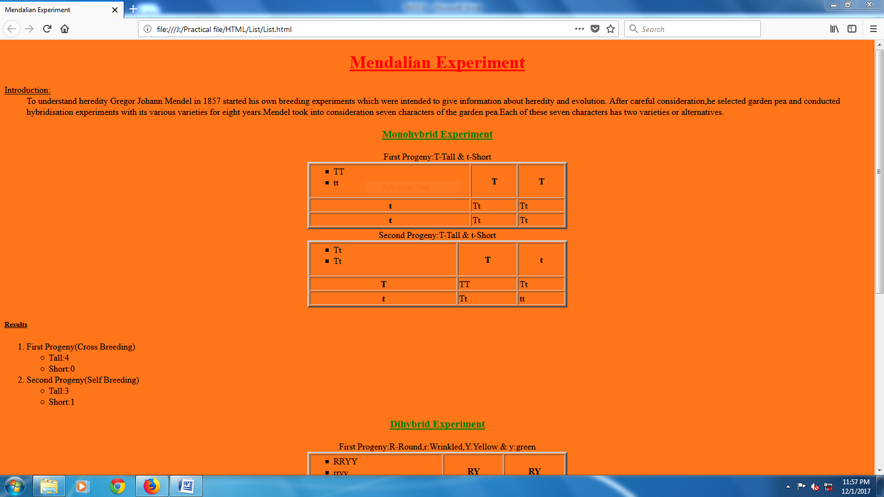

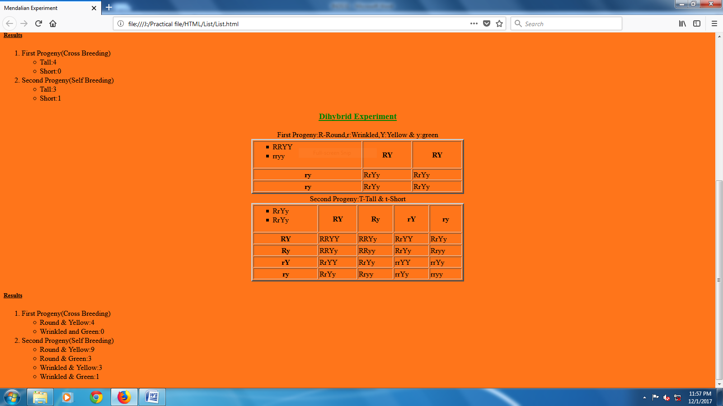

**9.Table with Images**

**Html Code**

<html>

<head>

<title>Indian Scientists</title>

</head>

<body bgcolor="yellow">

<table border="2"

width="40%"

align="center">

<caption><b><u>Our Real Heroes</u></b></caption>

<tr>

<th>C. V. Raman

<br>1888 – 1970

<td><img src="a.jpg"

width="100%"

height="100%">

<tr>

<th>Homi J. Bhabha

<br>1909 – 1966

<td><img src="b.jpg"

width="100%"

height="100%">

<tr>

<th>Satyendra Nath Bose

<br>1894 – 1974

<td><img src="c.jpg"

width="100%"

height="100%">

<tr>

<th>Srinivasa Ramanujan

<br>1887 – 1920

<td><img src="d.jpg"

width="100%"

height="100%">

</table>

</body>`

</html>

**Output**

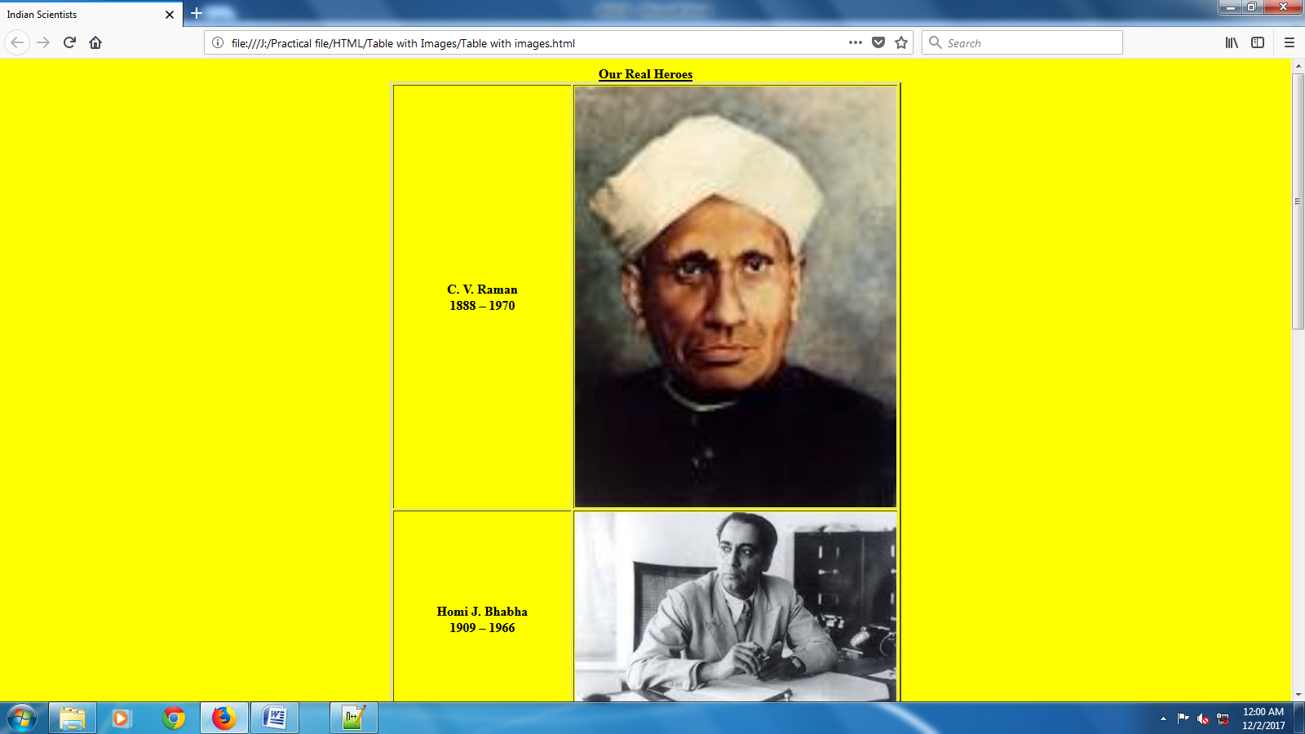

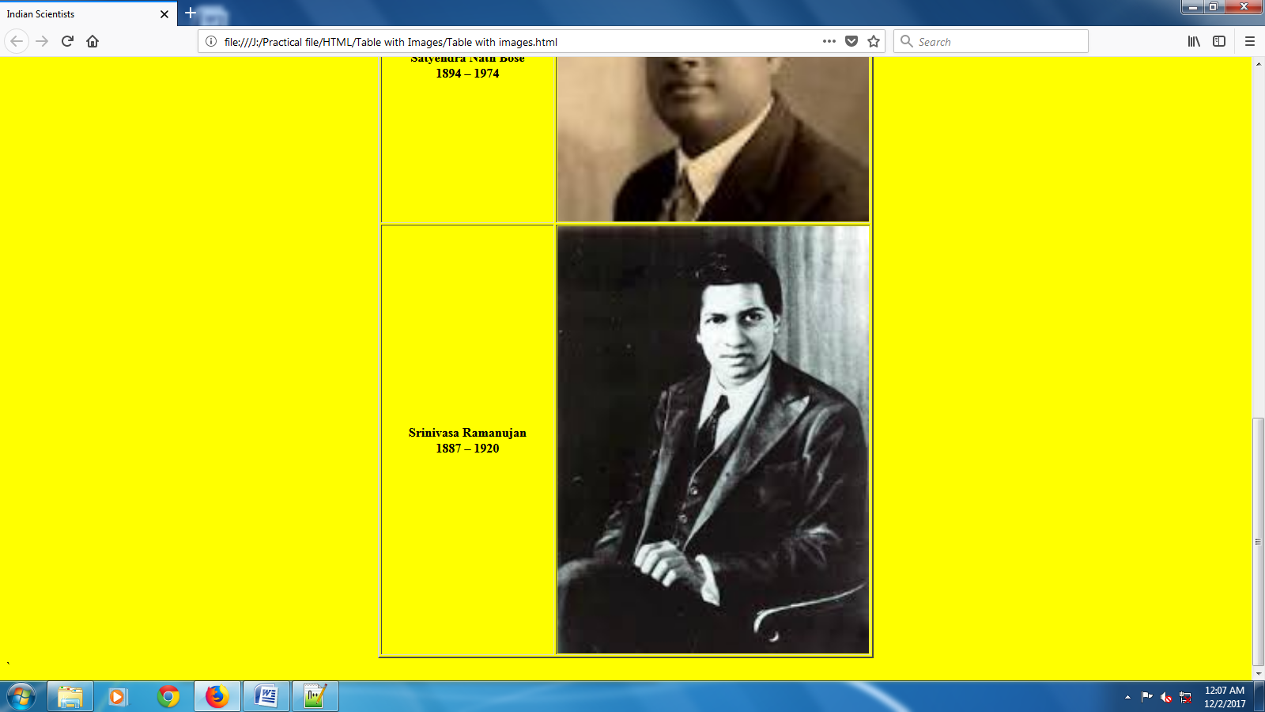

**10.Table**

**HTML Code**

<html>

<head>

<title>Time Table</title>

</head>

<body bgcolor="Yellow"

text="orange">

<font color="red">

<h1 align="center">Time Table</h1>

</font>

<table border="4"

bordercolor="white" align="center">

<tr color="White">

<th>

<th>1

<th>2

<th>3

<th>4

<th rowspan="7">R<br>

E<br>

C<br>

E<br>

S<br>

S<br>

<th>5

<th>6

<tr>

<th color="white">Monday

<td>Chemistry

<td>Physics

<td>Optional

<td>English

<td>Biology

<td>Chemistry

<tr>

<th color="white">Tuesday

<td>Chemistry

<td>Physics

<td>Optional

<td>English

<td>Biology

<td>Chemistry

<tr>

<th color="white">Wednesday

<td>Chemistry

<td>Physics

<td>Optional

<td>English

<td>Biology

<td>Biology

<tr>

<th color="white">Thursday

<td>Chemistry

<td>Physics

<td>Optional

<td>English

<td>Biology

<td>Biology

<tr>

<th color="white">Friday

<td>Chemistry

<td>Physics

<td>Optional

<td>English

<td>Biology

<td>Physics

<tr>

<th color="white">Saturday

<td>Chemistry

<td>Physics

<td>Optional

<td>English

<td>Biology

<td>Physics

</table>

</body>

</html>

**Output**

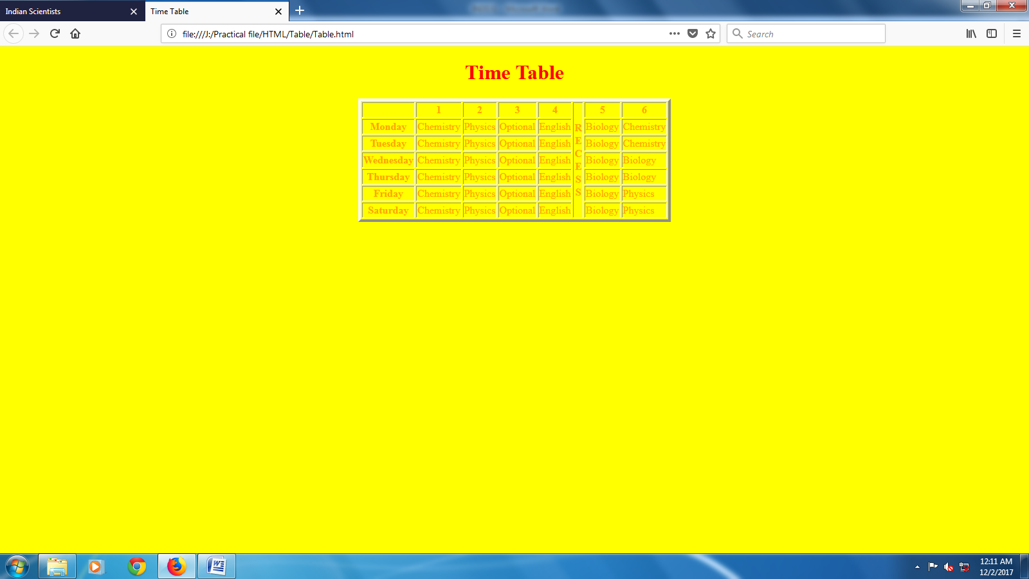

**INDEX**

* Div
* Alert Buttons
* Animated search box
* Classes
* Dropdown image
* Embedded css
* Fixed side nav
* Float and Clear
* Layers
* Styling Table With CSS
* Using Colors To Style List

**1.Div**

**HTML Code**

<html>

<head>

<title>Div</title>

<link href="div.css"

rel="stylesheet"

type="text/css">

<meta name="viewport"

content="width=device-width initial-scale=1">

</head>

<body>

<div>

<div style="height:20%;

width:100%;"><!-- Top -->

<div class="icon"><!-- Icon -->

<h3>ICON</h3>

</div>

<div class="header"><!-- Header -->

<h3>HEADER</h3>

</div>

<div class="address"><!-- Address -->

<h3>ADDRESS</h3>

</div>

</div>

<div style="height:70%;

width:100%;"><!-- Middle -->

<div class="navside"><!-- Nav side -->

<div class="navheader"><!-- Nav Header -->

<h3>NAV HEADER</h3>

</div>

<div class="navmenu"><!-- Nav Menu -->

<ul>

<li>ITEM 1<br/>

<li>ITEM 2<br/>

<li>ITEM 3<br/>

<li>ITEM 4<br/>

</ul>

</div>

<div class="navform"><!-- Nav Form -->

<h3>NAV FORM</h3>

</div>

</div>

<div class="mainbody"><!-- Main Body -->

<div class="menulist"><!-- Menu List -->

<ul class="menu">

<li>Home

<li>Gallery

<li>Contact Us

<li>Log-in

<li>About

</ul>

</div>

<div class="content"><!-- Content -->

<h3>CONTENT</h3>

</div>

</div>

<div class="adds"><!-- Addvertisement -->

<h3>ADDS</h3>

</div>

</div>

<div class="footer">

<h3>Footer</h3>

</div>

</div>

</body>

</html>

**CSS Code**

*

{

margin : 0 0 0 0;

padding : 0 0 0 0;

}

.icon

{

height : 100%;

width : 20%;

float : left;

background-color : #1E90FF;

color : white;

}

.header

{

height : 100%;

width : 70%;

float : left;

background-color : #CD5C5C;

color : white;

}

.address

{

height : 100%;

width : 10%;

float : left;

background-color : #FF69B4;

color : white;

}

.navside

{

height : 100%;

width : 20%;

float : left;

background-color :#CD5C5C;

}

.navheader

{

height : 5%;

width : 100%;

background-color :#4B0082;

color : white;

}

.navmenu

{

height : 25%;

width : 100%;

background-color :#F08080;

color : white;

}

.navmenu li

{

height : 25.1%;

width : 100%;

text-align:center;

list-style:none;

}

.navmenu li:hover

{

background-color: #FFA07A;

}

.navform

{

height : 50%;

width : 80%;

background-color : #87CEFA;

color : white;

margin: 10% 10% 10% 10%;

border-radius : 5px 5px;

}

.mainbody

{

height : 100%;

width : 70%;

float : left;

}

.menulist

{

height : 5%;

width : 100%;

float : left;

background-color :#FF4500;

color : white;

}

.menulist li

{

height : 100%;

width : 20%;

float : left;

text-align : center;

list-style : none;

}

.menulist li:hover

{

background-color : #FFA500;

}

.content

{

height : 95%;

width : 100%;

float : left;

background-color : #DB7093;

color:white;

}

.adds

{

height : 100%;

width : 10%;

float : left;

background-color : #CD853F;

color:white;

}

.footer

{

height : 10%;

width : 100%;

background-color : #FFC0CB;

color:white;

}

h3

{

text-align : center;

vertical-align : center;

}

**Output**

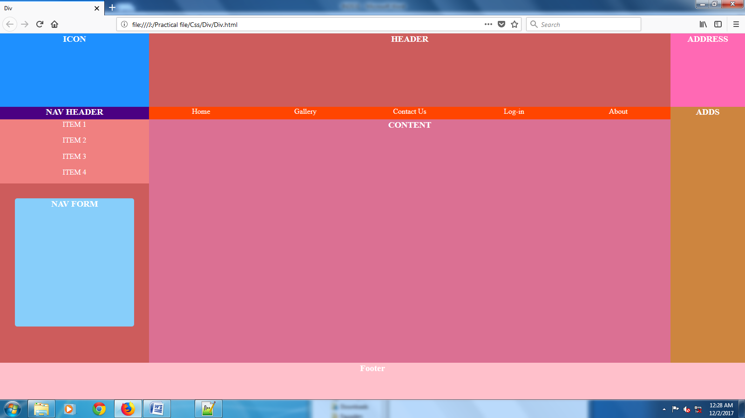

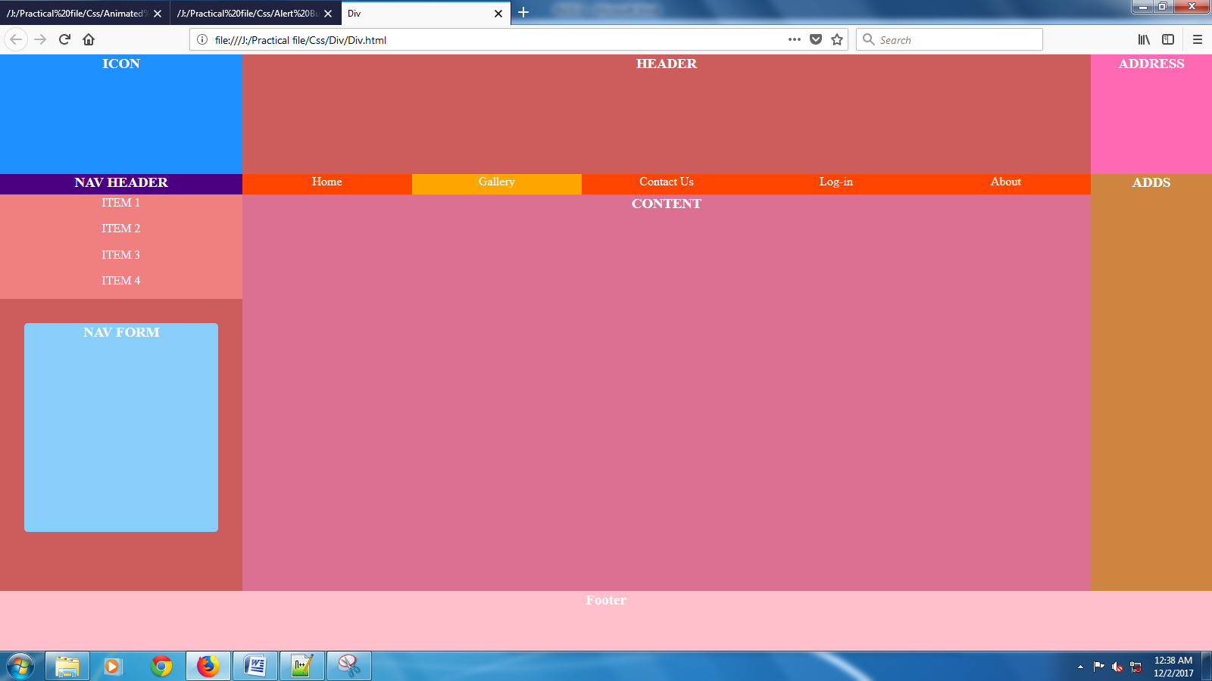

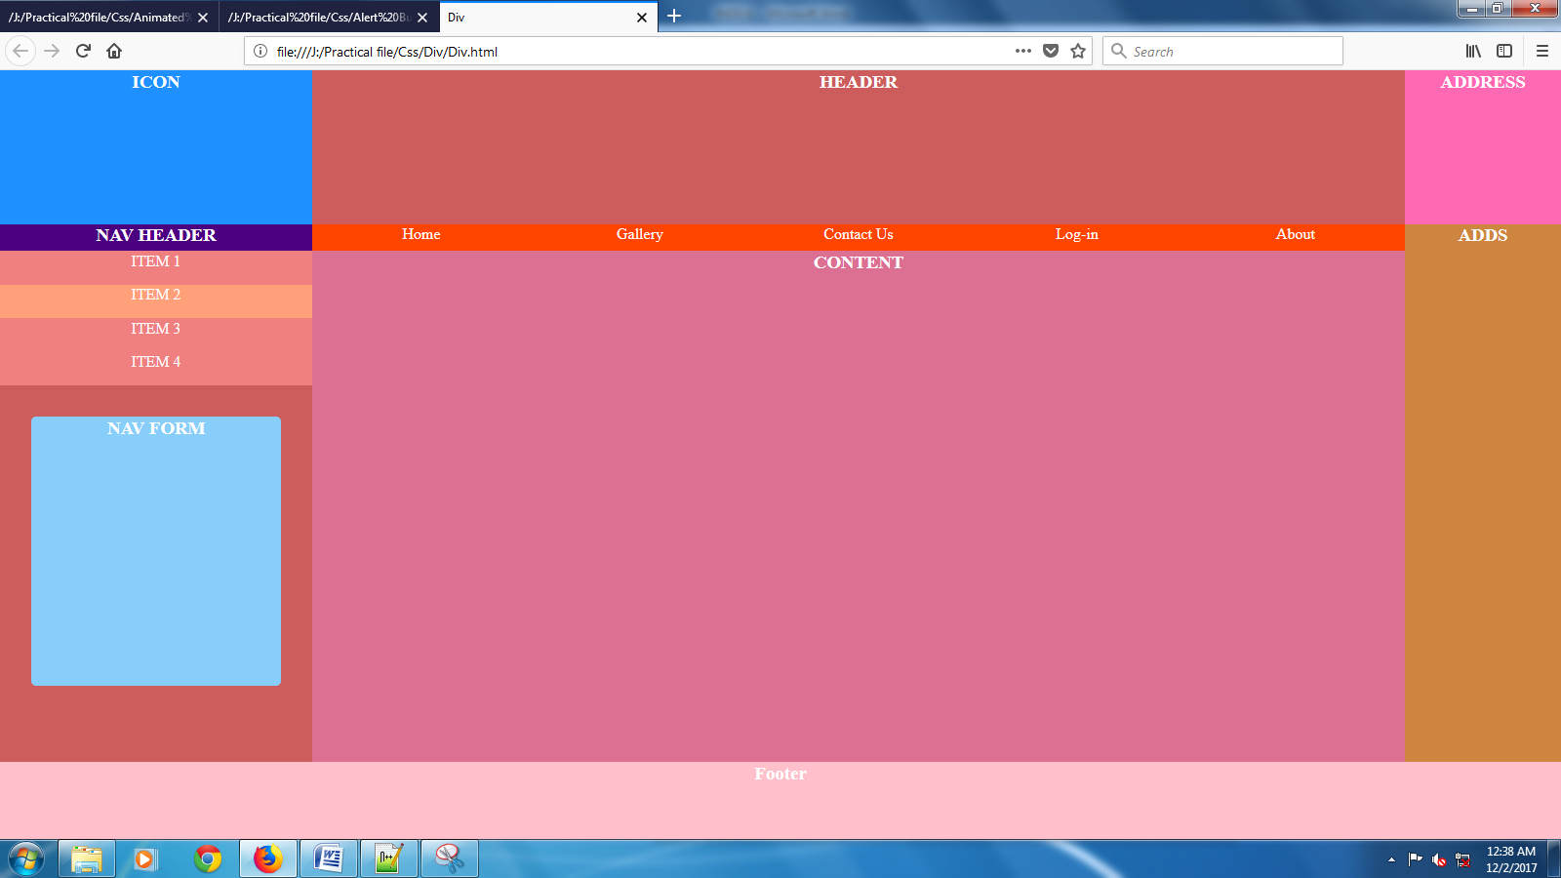

**2.Alert Buttons**

**HTML Code**

<html>

<head>

<style>

.btn

{

border: none;

color: white;

padding: 14px 28px;

font-size: 16px;

cursor: pointer;

}

.success

{

background-color: #4CAF50;

} /* Green */

.success:hover

{

background-color: #46a049;

}

.info

{

background-color: #2196F3;

} /* Blue */

.info:hover

{

background: #0b7dda;

}

.warning

{

background-color: #ff9800;

} /* Orange */

.warning:hover

{

background: #e68a00;

}

.danger

{

background-color: #f44336;

} /* Red */

.danger:hover

{

background: #da190b;

}

.default

{

background-color: #e7e7e7;

color: black;

} /* Gray */

.default:hover

{

background: #ddd;

}

</style>

</head>

<body bgcolor="#ff9999">

<h1 align="center"

style="color:red"><b><u>Alert Buttons</u></b></h1>

<center>

<button class="btn success">Success</button>

<button class="btn info">Info</button>

<button class="btn warning">Warning</button>

<button class="btn danger">Danger</button>

<button class="btn default">Default</button>

</body>

</html>

**Output**

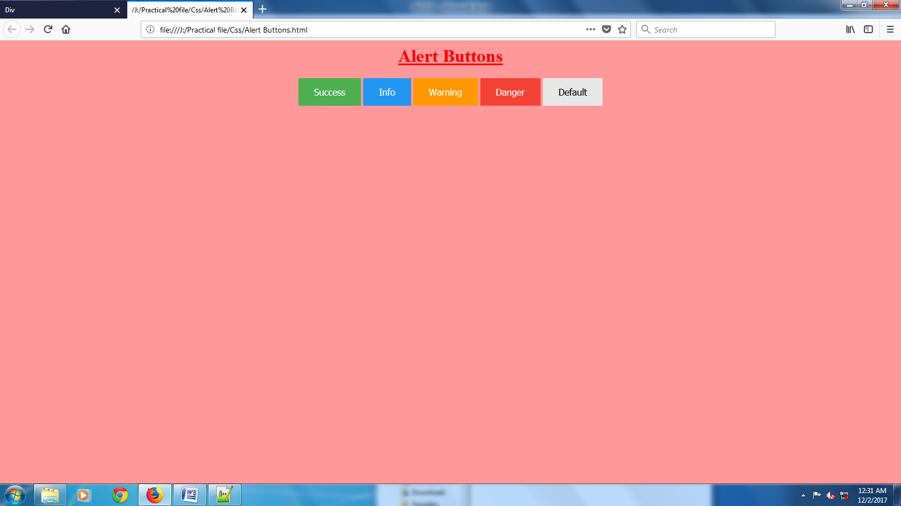

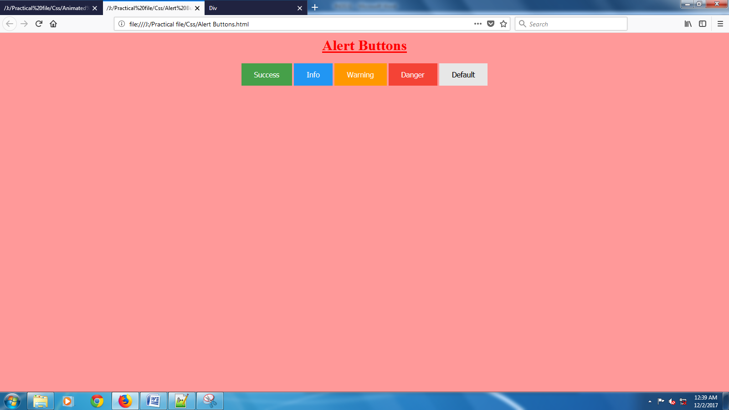

**3.Animated search box**

**HTML Code**

<html>

<head>

<style>

input[type=text]

{

width: 130px;

box-sizing: border-box;

border: 2px solid #ccc;

border-radius: 4px;

font-size: 16px;

background-color: white;

background-image: url('Images/search.png');

background-position: 10px 10px;

background-repeat: no-repeat;

padding: 12px 20px 12px 40px;

-webkit-transition: width 0.4s ease-in-out;

transition: width 0.4s ease-in-out;

}

input[type=text]:focus

{

width: 100%;

}

</style>

</head>

<body>

<p>Animated search input:</p>

<form>

<input type="text"

name="search"

placeholder="Search..">

</form>

</body>

</html>

**Output**

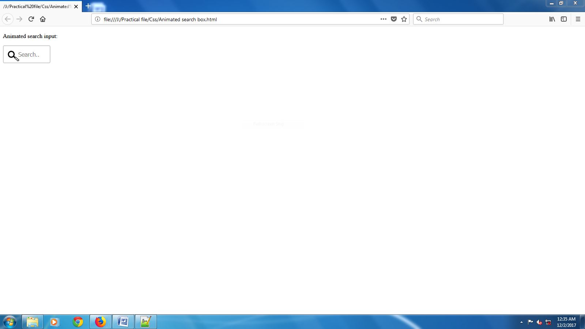

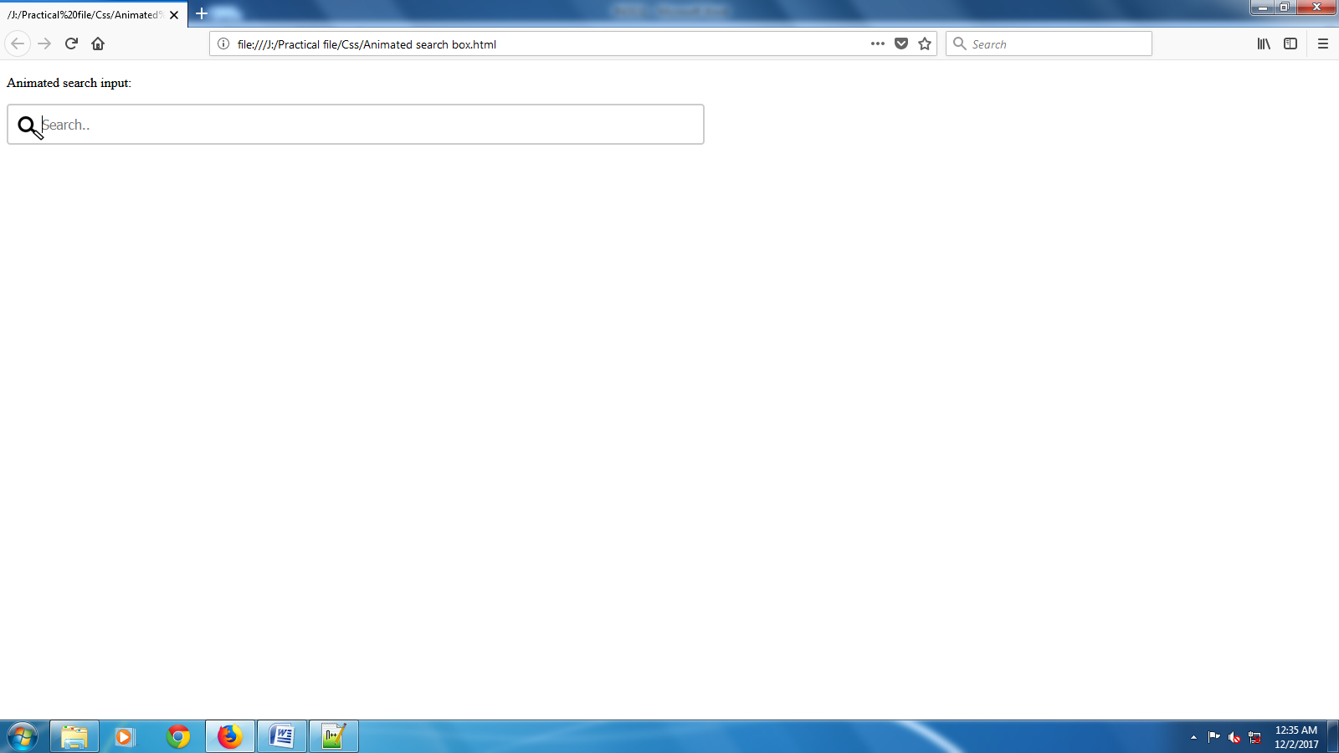

**4.Classes**

**HTML Code**

<html>

<head>

<style>

div.cities

{

background-color: black;

color: white;

margin: 20px 0 20px 0;

padding: 20px;

}

</style>

</head>

<body>

<div class="cities">

<h2>London</h2>

<p>London is the capital of England. It is the most populous city in the United Kingdom,

with a metropolitan area of over 13 million inhabitants.</p>

<p>Standing on the River Thames, London has been a major settlement for two millennia, its

history going back to its founding by the Romans, who named it Londinium.</p>

</div>

<div class="cities">

<h2>Paris</h2>

<p>Paris is the capital and most populous city of France.</p>

<p>Situated on the Seine River, it is at the heart of the Île-de-France region, also known as

the région parisienne.</p>

<p>Within its metropolitan area is one of the largest population centers in Europe, with over

12 million inhabitants.</p>

</div>

<div class="cities">

<h2>Tokyo</h2>

<p>Tokyo is the capital of Japan, the center of the Greater Tokyo Area, and the most populous

metropolitan area in the world.</p>

<p>It is the seat of the Japanese government and the Imperial Palace, and the home of the

Japanese Imperial Family.</p>

<p>The Tokyo prefecture is part of the world's most populous metropolitan area with 38 million

people and the world's largest urban economy.</p>

</div>

</body>

</html>

**Output**

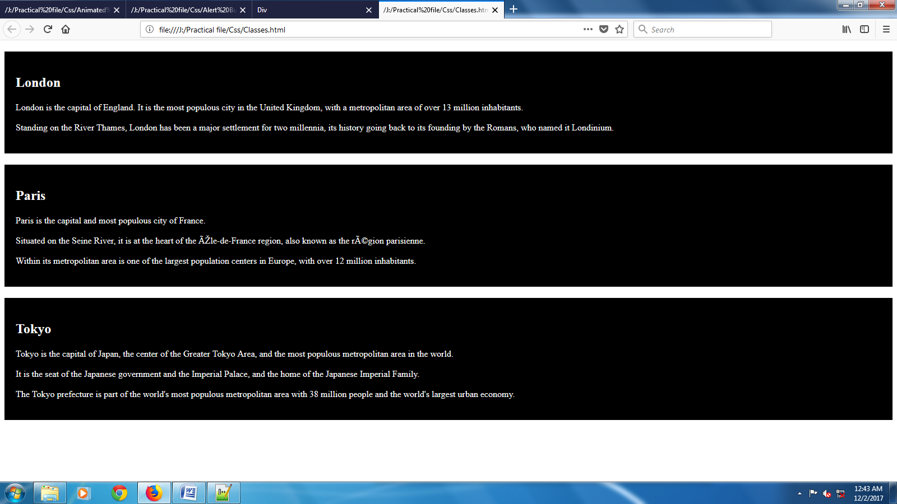

**5.Dropdown image**

**HTML Code**

<html>

<head>

<style>

.dropdown

{

position: relative;

display: inline-block;

}

.dropdown-content

{

display: none;

position: absolute;

background-color: #f9f9f9;

min-width: 160px;

box-shadow: 0px 8px 16px 0px rgba(0,0,0,0.2);

z-index: 1;

}

.dropdown:hover .dropdown-content

{

display: block;

}

.desc

{

padding: 15px;

text-align: center;

}

</style>

</head>

<body>

<h2>Dropdown Image</h2>

<p>Move the mouse over the image below to open the dropdown content.</p>

<div class="dropdown">

<img src="Images/img_fjords.jpg"

alt="Trolltunga Norway"

width="100"

height="50">

<div class="dropdown-content">

<img src="Images/img_fjords.jpg"

alt="Trolltunga Norway"

width="300"

height="200">

<div class="desc">Beautiful Trolltunga, Norway</div>

</div>

</div>

</body>

</html>

**Output**

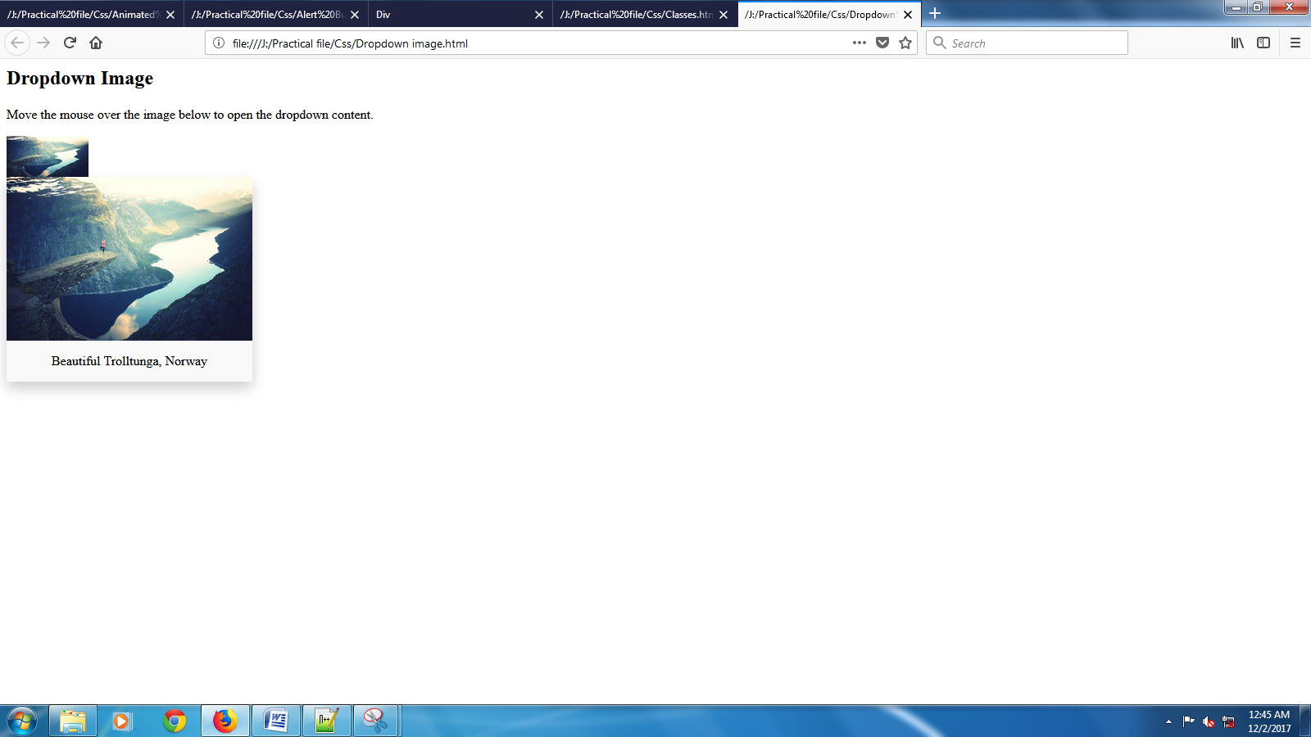

**6.Embedded css**

**HTML Code**

<html>

<head>

<title>

Dynamic List

</title>

<style>

.list2{background-color:none;

height:5%;

list-style:none;

text-align:center;

margin-top:20%;

margin-left:-1.5%;}

.list2 li{float:left;

list-style:none;

padding-top:1%;

background-color:black;

margin-left:0%;

height:100%;

width:24.87%;

border-right:1 white solid;

color:white;

border-radius:0;

vertical-align:center;}

.list2 li:hover{background-color:green;}

</style>

</head>

<body bgcolor="#F08080">

<div class="list2">

<ul>

<li>Home

<li>Gallery

<li>Contact

<li>About us

</ul>

</div>

</body>

</html>

**Output**

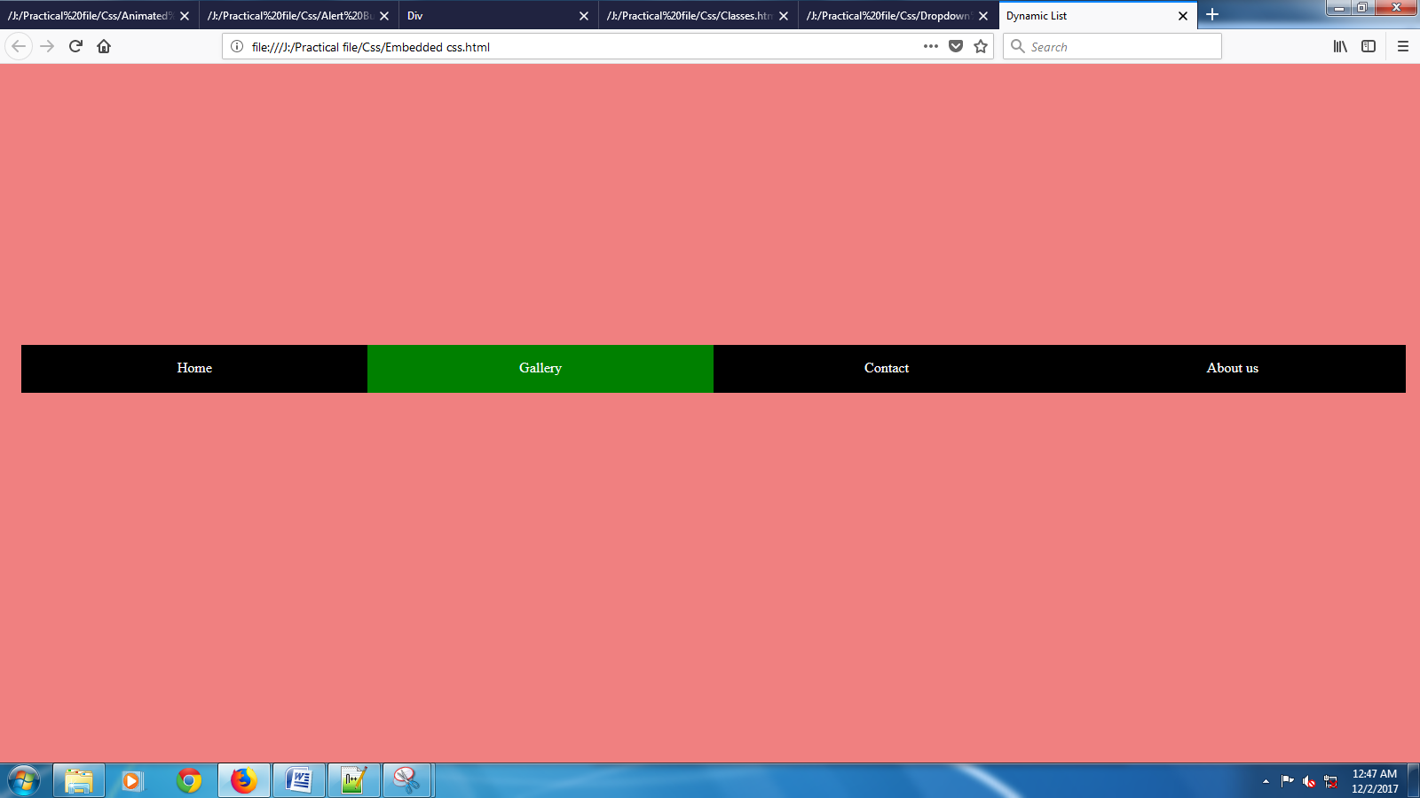

**7.Fixed side nav**

**HTML Code**

<html>

<head>

<style>

body

{

margin: 0;

}

ul

{

list-style-type: none;

margin: 0;

padding: 0;

width: 25%;

background-color: #f1f1f1;

position: fixed;

height: 100%;

overflow: auto;

}

li a

{

display: block;

color: #000;

padding: 8px 16px;

text-decoration: none;

}

li a.active

{

background-color: #3399ff;

color: white;

}

li a:hover:not(.active)

{

background-color: #555;

color: white;

}

</style>

</head>

<body>

<ul>

<li><a class="active" href="#home">Home</a></li>

<li><a href="#news">News</a></li>

<li><a href="#contact">Contact</a></li>

<li><a href="#about">About</a></li>

</ul>

<div style="margin-left:25%;padding:1px 16px;height:1000px;">

<h2>Fixed Full-height Side Nav</h2>

<h3>Try to scroll this area, and see how the sidenav sticks to the page</h3>

<p>This div element has a left margin of 25%. This is because the side navigation is set to 25% width. If we remove the margin, the sidenav will overlay/sit on top of this div.</p>

<p>Also we have set overflow:auto to sidenav. This will add a scrollbar when the sidenav is too long (for example if it has over 50 links inside of it).</p>

<p>Some text..</p>

<p>Some text..</p>

<p>Some text..</p>

<p>Some text..</p>

<p>Some text..</p>

<p>Some text..</p>

<p>Some text..</p>

</div>

</body>

</html>

**Output**

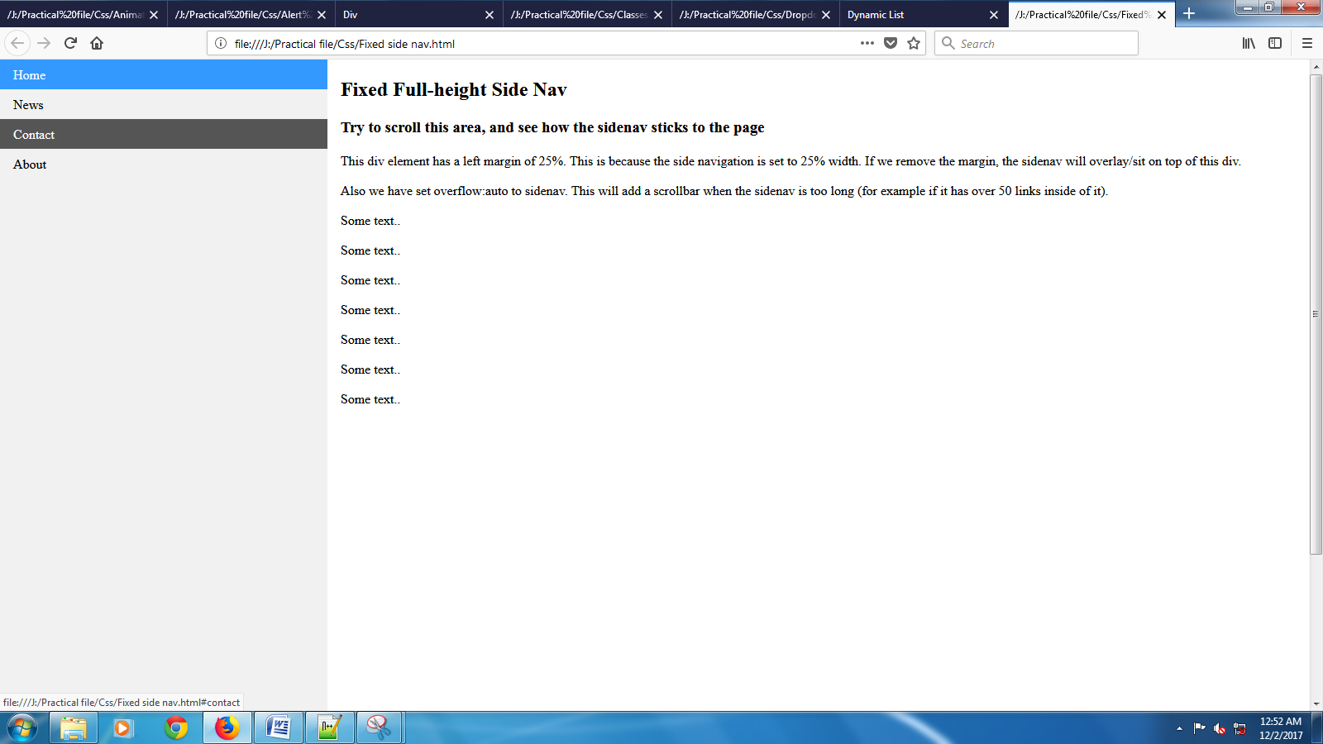

**8.Float and Clear**

**HTML Code**

<html>

<head>

<style>

*

{

box-sizing: border-box;

}

.header, .footer

{

background-color: grey;

color: white;

padding: 15px;

}

.column

{

float: left;

padding: 15px;

}

.clearfix::after

{

content: "";

clear: both;

display: table;

}

.menu

{

width: 25%;

}

.content

{

width: 75%;

}

.menu ul

{

list-style-type: none;

margin: 0;

padding: 0;

}

.menu li

{

padding: 8px;

margin-bottom: 8px;

background-color: #33b5e5;

color: #ffffff;

}

.menu li:hover

{

background-color: #0099cc;

}

</style>

</head>

<body>

<div class="header">

<h1>Chania</h1>

</div>

<div class="clearfix">

<div class="column menu">

<ul>

<li>The Flight</li>

<li>The Flight</li>

<li>The City</li>

<li>The Island</li>

<li>The Food</li>

</ul>

</div>

<div class="column content">

<h1>The City</h1>

<p>Chania is the capital of the Chania region on the island of Crete.

The city can be divided in two parts, the old town and the modern city.</p>

<p>You will learn more about web layout and responsive web pages in a later chapter.</p>

</div>

</div>

<div class="footer">

<p>Footer Text</p>

</div>

</body> </html>

**Output**

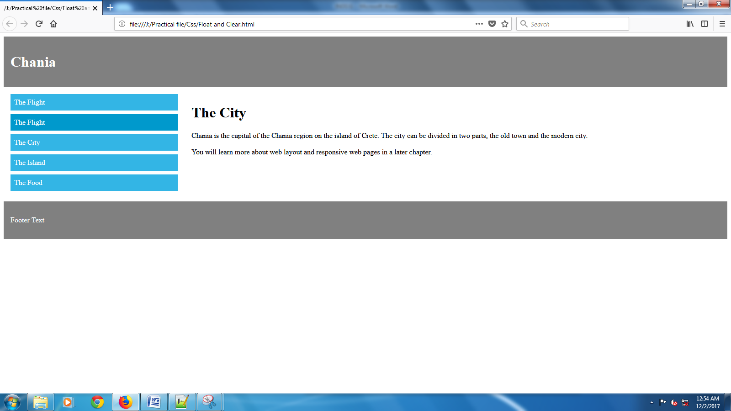

**9.Layers**

**HTML Code**

<html>

<head>

<title>Layers</title>

<style>

#a{position:absolute;

left: 1%;

top: 1%;

z-index: 1;}

#b{position: absolute;

left: 10%;

top: 10%;

z-index: 2;}

#c{position:absolute;

left: 20%;

top: 30%;

z-index: 3;}

#d{position:absolute;

left: 40%;

top: 40%;

z-index: 4;}

#e{position:absolute;

left: 50%;

top: 50%;

z-index: 5;}

</style>

</head>

<body bgcolor="red">

<img src="Images/i.jpg"

id="a"

height="30%"

width="30%">

<img src="Images/ii.png"

id="b"

height="30%"

width="30%">

<img src="Images/iii.jpg"

id="c"

height="30%"

width="30%">

<img src="Images/iv.jpg"

id="d"

height="30%"

width="30%">

<img src="Images/v.jpg"

id="e"

height="30%"

width="30%">

</body>

</html>

**Output**

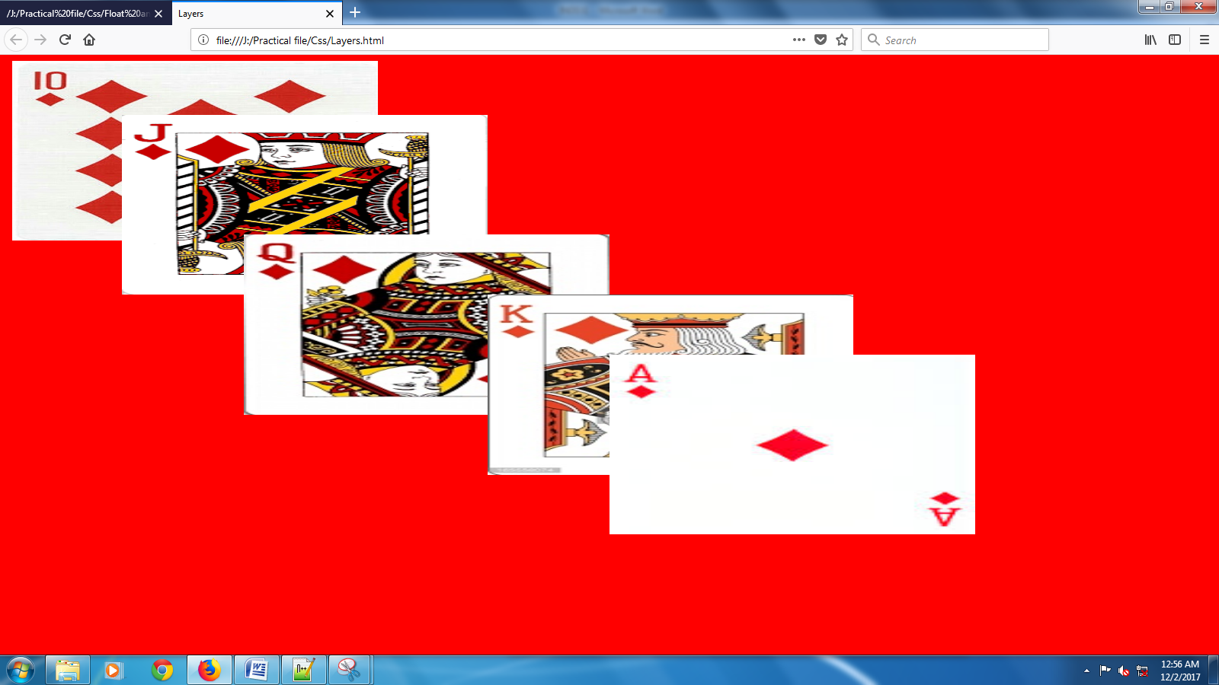

**10.Styling Table With CSS**

**HTML Code**

<html>

<head>

<style>

table

{

border-collapse: collapse;

width: 100%;

}

th, td

{

text-align: left;

padding: 8px;

}

tr:nth-child(even)

{

background-color: #f2f2f2

}

tr:hover

{

background-color: #ccffcc

}

th

{

background-color: #4CAF50;

color: white;

}

</style>

</head>

<body>

<table>

<tr>

<th>Company</th>

<th>Contact</th>

<th>Country</th>

</tr>

<tr>

<td>Alfreds Futterkiste</td>

<td>Maria Anders</td>

<td>Germany</td>

</tr>

<tr>

<td>Berglunds snabbköp</td>

<td>Christina Berglund</td>

<td>Sweden</td>

</tr>

<tr>

<td>Centro comercial Moctezuma</td>

<td>Francisco Chang</td>

<td>Mexico</td>

</tr>

<tr>

<td>Ernst Handel</td>

<td>Roland Mendel</td>

<td>Austria</td>

</tr>

<tr>

<td>Island Trading</td>

<td>Helen Bennett</td>

<td>UK</td>

</tr>

<tr>

<td>Königlich Essen</td>

<td>Philip Cramer</td>

<td>Germany</td>

</tr>

<tr>

<td>Laughing Bacchus Winecellars</td>

<td>Yoshi Tannamuri</td>

<td>Canada</td>

</tr>

<tr>

<td>Magazzini Alimentari Riuniti</td>

<td>Giovanni Rovelli</td>

<td>Italy</td>

</tr>

</table> </body> </html>

**Output**

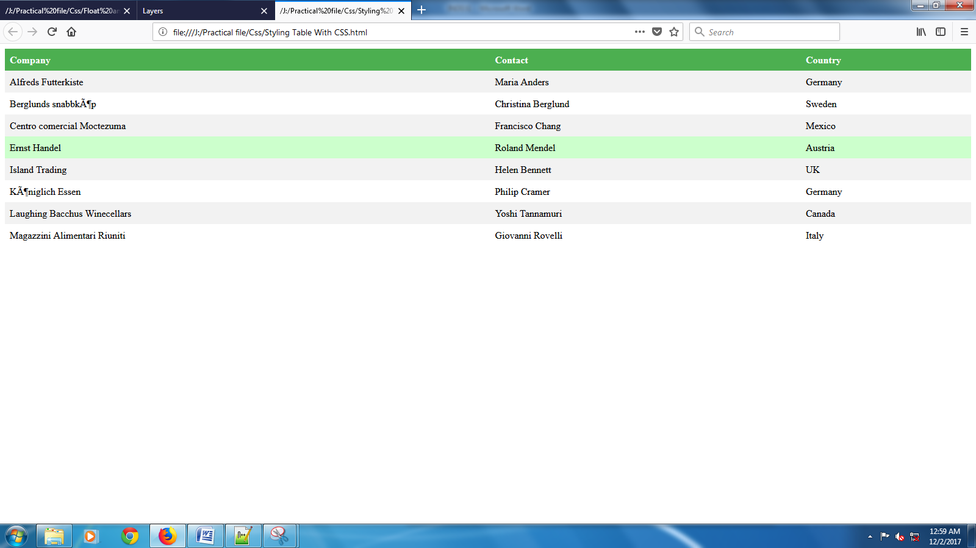

**11.** **Using Colors To Style List**

**HTML Code**

<html>

<head>

<style>

ol

{

background: #ff9999;

padding: 20px;

}

ul

{

background: #3399ff;

padding: 20px;

}

ol li

{

background: #ffe5e5;

padding: 5px;

margin-left: 35px;

}

ul li

{

background: #cce5ff;

margin: 5px;

}

</style>

</head>

<body>

<h1>Styling Lists With Colors:</h1>

<ol>

<li>Coffee</li>

<li>Tea</li>

<li>Coca Cola</li>

</ol>

<ul>

<li>Coffee</li>

<li>Tea</li>

<li>Coca Cola</li>

</ul>

</body>

</html>

**Output**

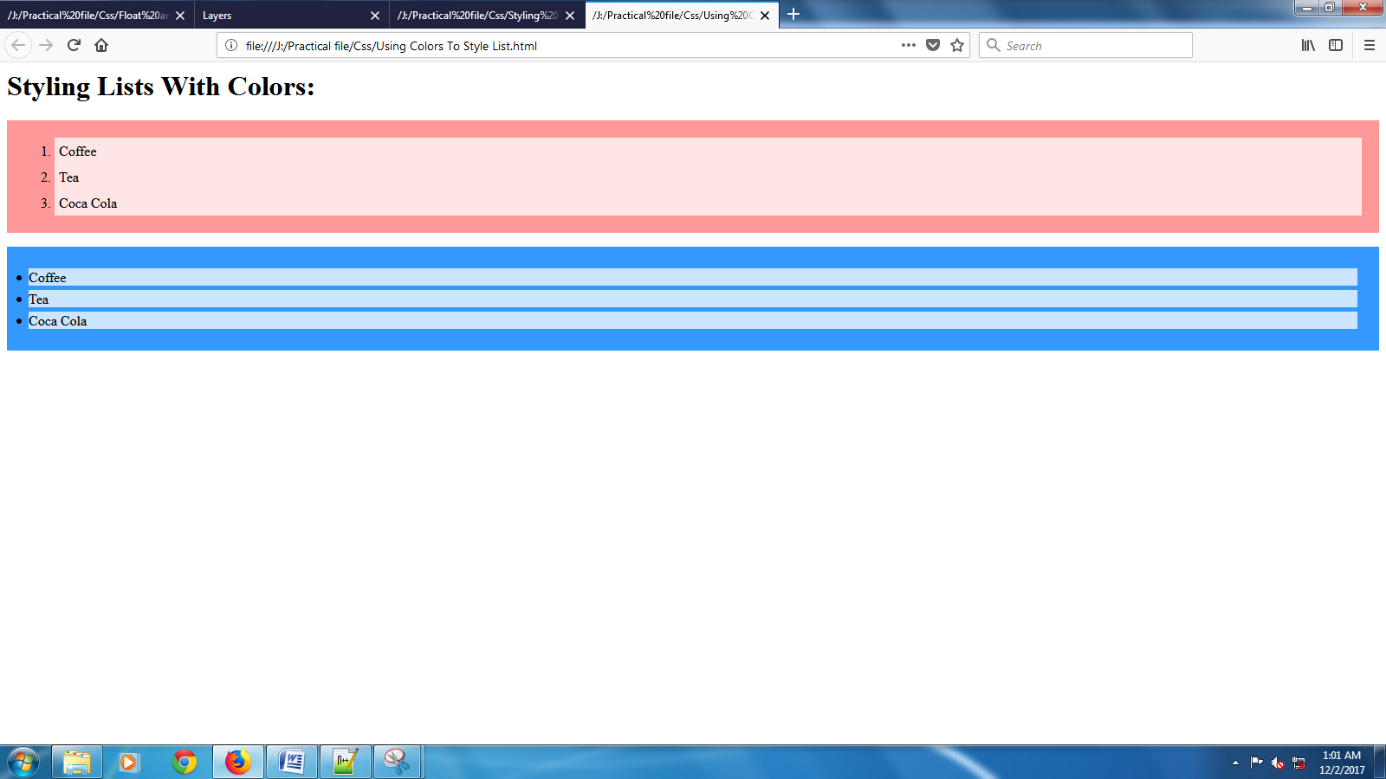

**INDEX**

* Array
* Calculator
* Form Validation
* It’s Magic
* Player
* Roman Numerals
* Shopping
* Sorting of positive real numbers
* Sum of n natural numbers
* Time

**1.Array**

**HTML Code**

<html>

<head>

<title>

Dynamic array to get multiplied by any number

</title>

<script>

function array_1()

{

var a=0;

var a=parseInt(prompt("How many numbers do you want to enter?"));

var b=parseInt(prompt("With Which Number Do You want to multiply"));

var array_1=Array(a);

document.write("Array Entered is: ");

for(count=0;count<a;count++)

{

array_1[count]= parseInt(prompt("Enter the"+(count+1)+"st number"));

if(count<(a-1))

{

document.write(array_1[count]+",");

}

else

{

document.write(array_1[count]+"");

}

}

document.write("<br>New array: ");

for(i=0;i<a;i++)

{

result=array_1[i]*b;

if(i<(a-1))

{

document.write(result+",");

}

else

{

document.write(result+"");

}

}

}

</script>

</head>

<body onload="array_1()">

</body>

</html>

**Output**

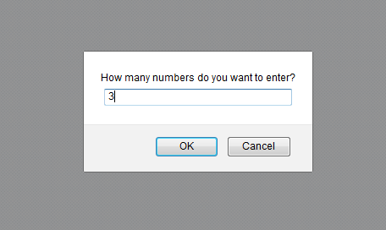

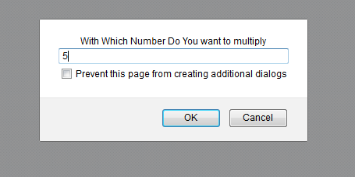



**2.Calculator**

**HTML Code**

<html>

<head>

<title>

Calcularor

</title>

<script type="text/javascript">

function name1()

{

var name2=prompt("Enter Your Name");

if(name2==null)

{

frm.txt4.value="\t Hi! Friend";

}

else

{

frm.txt4.value="\t Hi!"+" "+name2;

}

}

function sum()

{

frm.txt3.value=parseInt(frm.txt1.value)+parseInt(frm.txt2.value);

}

function sub()

{

frm.txt3.value=parseInt(frm.txt1.value)-parseInt(frm.txt2.value);

}

function multi()

{

frm.txt3.value=parseInt(frm.txt1.value)*parseInt(frm.txt2.value);

}

function div()

{

frm.txt3.value=parseInt(frm.txt1.value)/parseInt(frm.txt2.value);

}

function modulus()

{

frm.txt3.value=parseInt(frm.txt1.value)%parseInt(frm.txt2.value);

}

function salary()

{

var salary1=prompt("Enter your Salary of one day");

frm.txt3.value=salary1*30;

}

function voting1()

{

var voting2=prompt("Enter your age");

var e="Eligible";

var ne="Not-Eligible";

frm.txt3.value=(voting2>18?e:ne);

}

function eval1()

{

frm.txt3.value=eval(prompt("Enter The function"));

}

function grade1()

{

var marks1=parseInt(prompt("Enter Your Marks"));

if((marks1>=90)&&(marks1<100))

{

frm.txt3.value="A";

}

else if((marks1>=80)&&(marks1<90))

{

frm.txt3.value="B";

}

else if((marks1>=70)&&(marks1<80))

{

frm.txt3.value="C";

}

else if((marks1>=60)&&(marks1<70))

{

frm.txt3.value="D";

}

else if((marks1>=50)&&(marks1<60))

{

frm.txt3.value="E";

}

else if((marks1>=40)&&(marks1<50))

{

frm.txt3.value="F";

}

else

{

frm.txt3.value="FAIL!";

}

}

</script>

</head>

<body bgcolor="#E9967A"

onload="name1()"

background="Images/1.svg">

<h1 style="color:#CD5C5C">

<center>

<u>

Calculator

</u>

</center>

</h1>

<form name="frm">

<center>

<table border="1"

background="Images/4.jpg">

<tbody>

<tr>

<td colspan="2">

<center>

<input type="text"

name="txt4"

value="Hi! friend"

readonly>

</center>

</td>

</tr>

<tr>

<td>

<b>

Enter First Value

</b>

</td>

<td>

<input type="text"

name="txt1"

size="8%">

</td>

</tr>

<tr>

<td>

<b>

Enter second Value

</b>

</td>

<td>

<input type="text"

name="txt2"

size="8%">

</td>

</tr>

<tr>

<td>

<center>

<input type="button"

value="+"

onclick="sum()">

</center>

</td>

<td>

<center>

<input type="button"

value="-"

onclick="sub()">

</center>

</td>

</tr>

<tr>

<td>

<center>

<input type="button"

value="*"

onclick="multi()">

</center>

</td>

<td>

<center>

<input type="button"

value="/"

onclick="div()">

</center>

</td>

</tr>

<tr>

<td>

<center>

<input type="button"

value="%"

onclick="modulus()">

</center>

</td>

<td>

<center>

<input type="button"

value="Salary"

onclick="salary()">

</center>

</td>

</tr>

<tr>

<td>

<center>

<input type="button"

value="Voting"

onclick="voting1()">

</center>

</td>

<td>

<center>

<input type="button"

value="Evaluate"

onclick="eval1()">

</center>

</td>

</tr>

<tr>

<td colspan="2">

<center>

<input type="button"

value="Grade"

onclick="grade1()">

</center>

</td>

</tr>

<tr>

<td>

<b>

Result

</b>

</td>

<td>

<input type="text"

name="txt3"

size="8%"

readonly>

</td>

</tr>

<tr>

<td colspan="2">

<center>

<input type="Reset"

value="Reset">

</td>

</tr>

</tbody>

</table>

</center>

</form>

</body>

</html>

**Output**

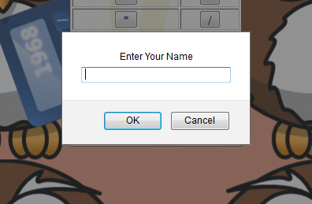

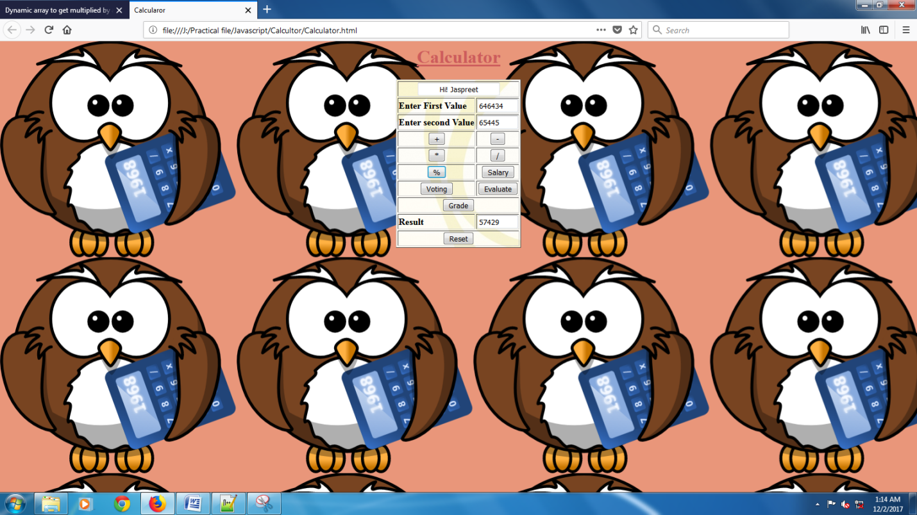

**3.Form Validation**

**HTML Code**

<html>

<body>

<script type="text/javascript">

function validate()

{

var name=document.myform.name.value;

var passwordlength=document.myform.password.value.length;

var status=false;

if(name=="")

{

document.getElementById("namelocation").innerHTML= " <img src='unchecked.gif'/> Please enter your name";

status=false;

}

else

{

document.getElementById("namelocation").innerHTML=" <img src='checked.gif'/>";

status=true;

}

if(passwordlength<6)

{

document.getElementById("passwordlocation").innerHTML= " <img src='unchecked.gif'/> Password must be greater than 6";

status=false;

}

else

{

document.getElementById("passwordlocation").innerHTML=" <img src='checked.gif'/>";

}

return status;

}

</script>

<form name="myform"

onsubmit="return validate()">

<table>

<tr>

<td>Name:

<td><input type="text"

name="name"/>

<span id="namelocation"

style="color:red"></span>

<tr>

<td>Password:

<td><input type="password"

name="password"/>

<span id="passwordlocation"

style="color:red"></span>

<tr>

<td colspan="2">

<input type="submit"

value="Register"/>

</table> </form> </body> </html>

**Output**

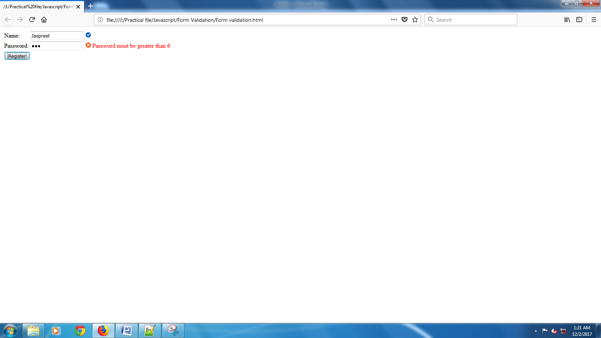

**4.It’s Magic**

**HTML Code**

<html>

<head>

<title>Magic with numbers</title>

<script>

function magic()

{

alert("Let any number");

alert("Let the same number for your friend");

var m=parseInt(prompt("Consider my number as per your wish be:"));

alert("Add up all of them");

alert("Half the sum & just forget about the one half");

alert("Now return your friend his number");

alert("Now don't shock because you are left with "+(m/2)+" number");

alert("That's it!");

}

</script>

</head>

<body onload="magic()">

</body> </html>

**Output**

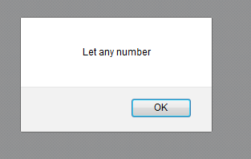

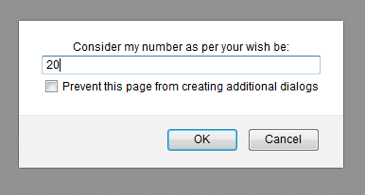

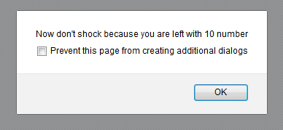

**5.Player**

**HTML Code**

<html>

<head>

<link href="css/styles.css" rel="stylesheet">

</head>

<body>

<script>

function player()

{

this.name=prompt("Enter Player "+(i+1)+"'s name");

this.hits=prompt("Enter no. of hits");

this.strikeouts=prompt("Enter no. of strikeouts");

this.atbats=prompt("Enter no. of at bats");

this.homeruns=prompt("Enter no. of home runs");

this.average=averages;

}

function averages()

{

players[i].average=parseInt(hits)/parseInt(atbats);

return players[i].average;

}

var val=parseInt(prompt("Enter the no. of players"));

var players=Array(val);

for(i=0;i<val;i++)

{

players[i]=new player();

name=players[i].name;

hits=players[i].hits;

strikeouts=players[i].strikeouts;

atbats=players[i].atbats;

homeruns=players[i].homeruns;

document.write("<B>" + "<U>" + "Name of player " + (i+1) + " is:" + name + "</u>" + "</B>" + "<br>" +

"Total no. of hits:"+hits+"<br>"+

"Total no. of strikeouts:"+strikeouts+"<br>"+

"Total no. of at bats:"+atbats+"<br>"+

"Total no. of homeruns:"+homeruns+"<br>"+

"Average:"+averages()+"<br>");

}

</script>

</body>

</html>

**Output**

